Topic Work Year 3 and 4 - Wednesday 3rd June - Mountains
https://www.bbc.co.uk/bitesize/articles/zbqsvk7
Watch this clip by following the link above  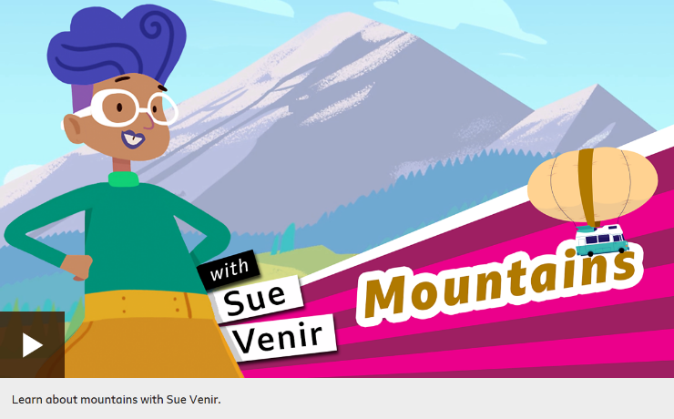 | Activity one  Play this quiz from the link above.  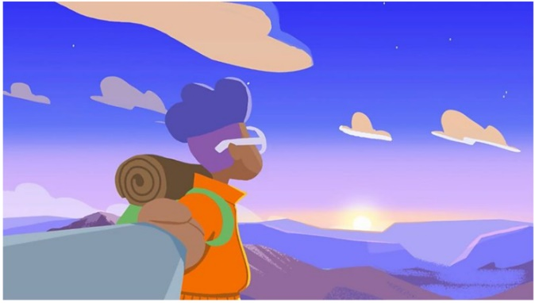
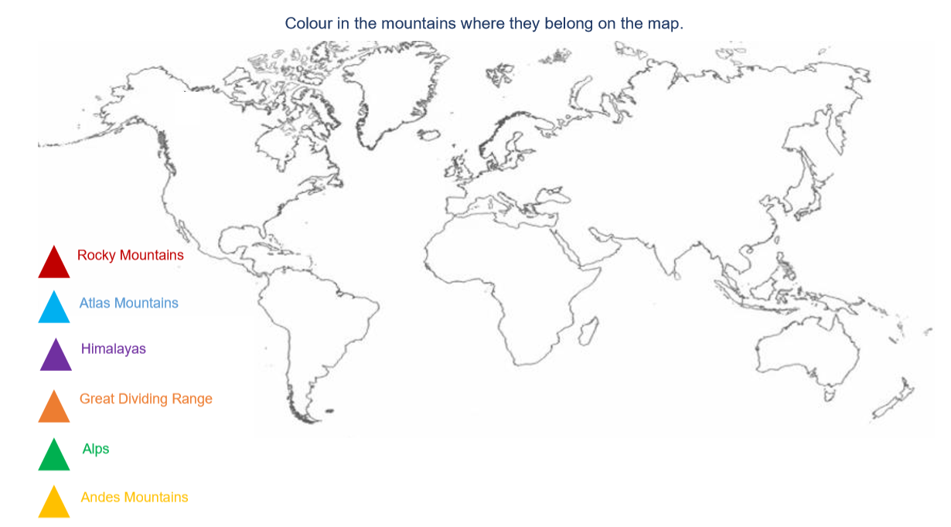
Activity 2 Here is a map of the world. Along the side are the names of the main mountain ranges around the world. Use the internet to help you find where these mountains are located. Can you find the continents and countries they are in?

