Science Year 3 and 4 The Force of Friction Wednesday 3rd June 2020
https://www.bbc.co.uk/bitesize/articles/z6xckmn
Watch the clip by following the link above  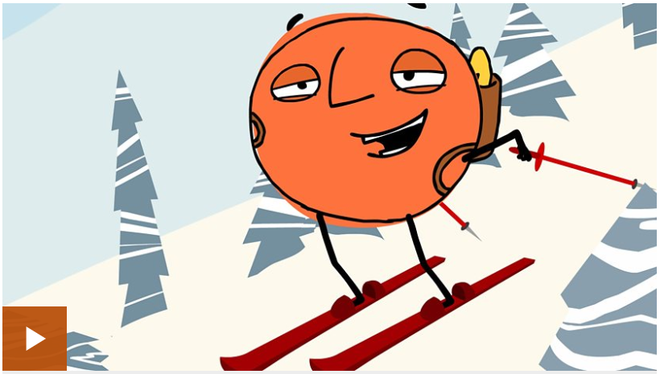  Now read the information about friction that follows the clip, on the BBC website. | Activity one  See how much you’ve remembered and learned by taking this quiz to fill in the gaps with your friction knowledge:  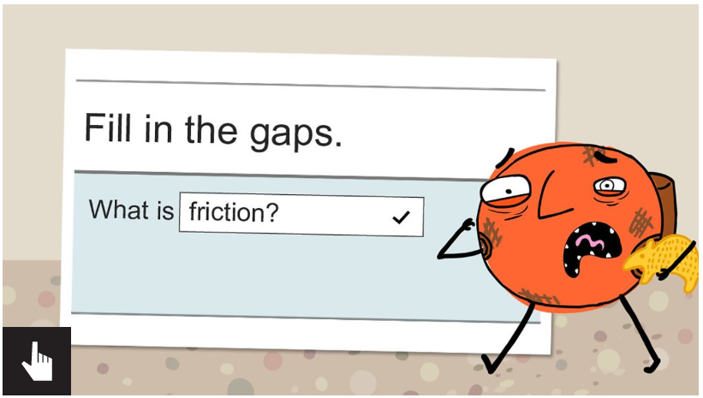
Activity 2  How many examples of friction can you think of, name, and explain whether that type of friction is useful or not useful? Have a go at completing the Friction worksheet:  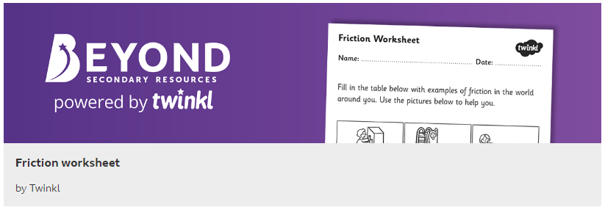 | Activity 3 Toy Car Experiment!  You will need: a toy car (or any small toy vehicle with wheels), something to make a ramp with (a plank, a long piece of stiff cardboard, maybe a big book?) a variety of materials for the car to travel across (material – a t-shirt, plastic – a worktop surface, wood – the floor or a table, a bumpy surface – rug/carpet, a rough surface – grass, any other surface ideas you might have within your home), and a tape measure.  Method: set up the car and the ramp on each surface (trying to be as fair as possible, keeping the ramp the same, and held at the same height). Run the car down the ramp and use the tape measure to see how far away from the bottom of the ramp your car travelled. Can you answer these questions?  - Which surface allowed the car to travel the furthest? What was the surface like?  - On which surface did the car travel the least distance? What was that surface like?  - Can you explain to a family member how friction has caused your toy car to travel different distances over different surfaces?  Here is a youtube clip to give you an idea of how to set this experiment up – don’t worry about timing yours, just measure the distance! Have fun! https://www.youtube.com/watch?v=yuvkaeMUT50

