Science Year 3 and 4 Renewable and non-renewable energy Wednesday 17th June 2020
https://www.bbc.co.uk/bitesize/articles/zm9jmyc
Watch the clip by following the link above  1 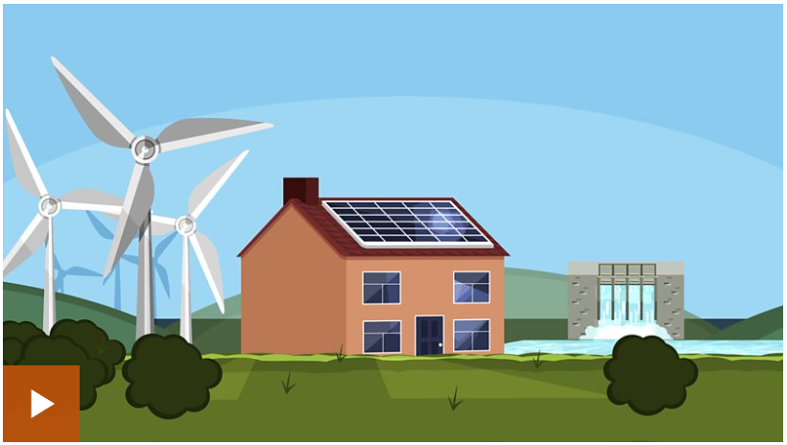 2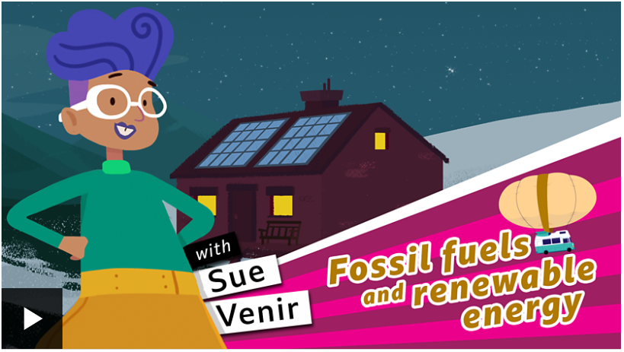  Read the information about renewable and non-renewable energy that follows the first clip on the BBC website, then watch the second clip to recap! | Activity one  Have fun building completing the ‘fill the gap’ activity.  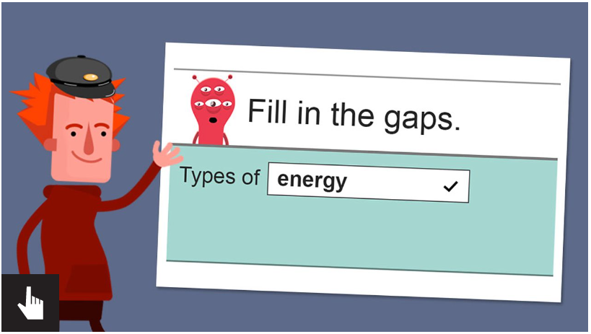
Activity Two  Test out your knowledge by taking the online quiz:  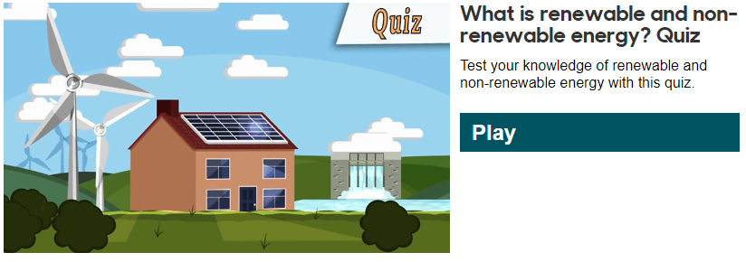 | Activity Three  Create a poster about what you have learned about renewable and non-renewable energy. Use the pdf ‘Advantages and disadvantages of renewable energy’ to help you add more information and detail to your poster.  Try to make your poster as bright, colourful and interesting as possible. Think about including:  - What the different types of energies are, within the renewable and non-renewable sections  - Draw some pictures to illustrate  - Some of the advantages and disadvantages (pick the ones you think are most important)  - What you think might be best for our environment  If you can take a photo of your work and email it in to the office we would love to see it!

