Topic Work Year 3 and 4 - Wednesday 17th June - Biomes
https://www.bbc.co.uk/bitesize/articles/zbnc86f
Watch this clip by following the link above  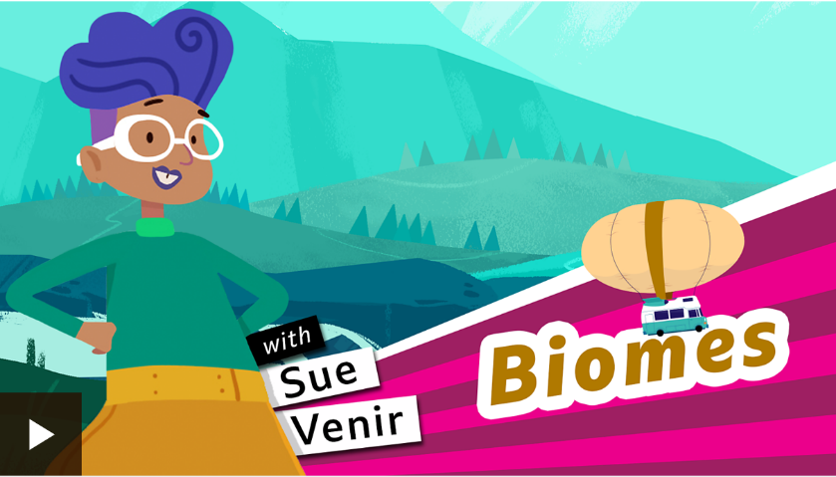 | Activity one  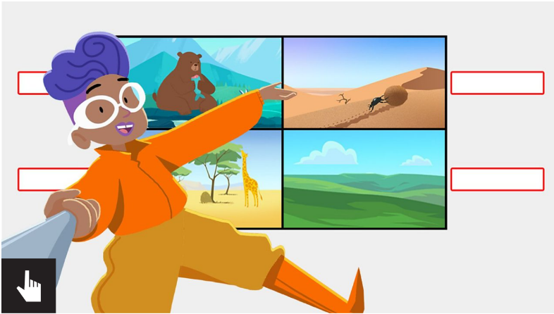  Play this game where you match the word with the picture. Follow the link above to find it.
Activity Two  Read through the PowerPoint (sent separately) with an adult to understand where in the world the different biomes are.  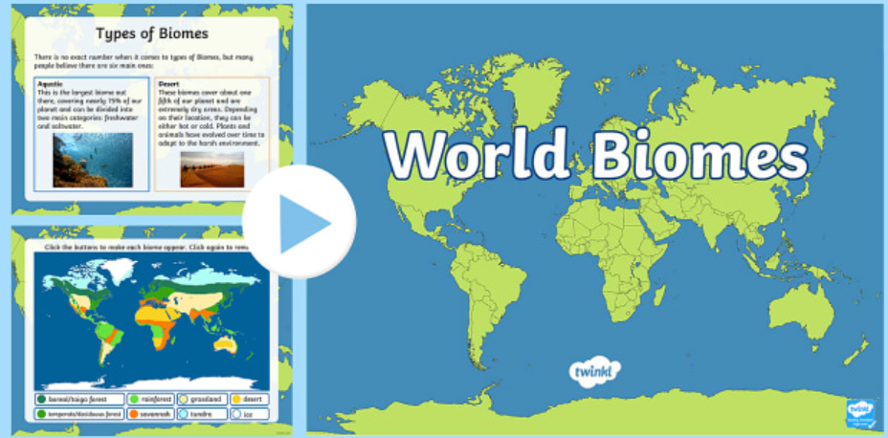 | Activity Three  Please follow this link from the BBC bitesize site to find the Britannica Digital Learning site.  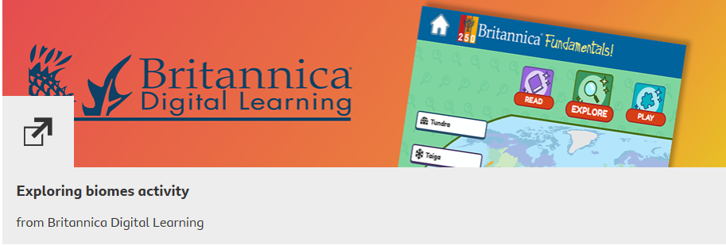  Click the link above to find this page:  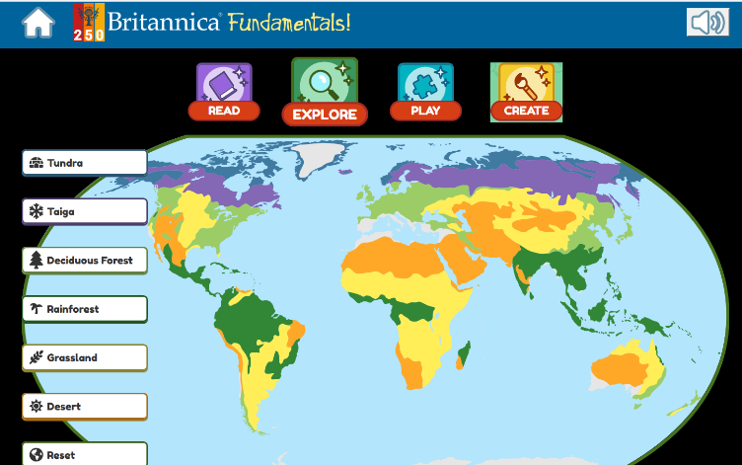  When you click a biome from the left-hand side it will appear on the world map and a learning clip to watch should also appear.

