Science Year 3 and 4 The Digestive System and Teeth! Wednesday 24th June 2020
https://www.bbc.co.uk/bitesize/articles/z3nhjsg
Watch the 6 clips by following the link above  I know that if you are in Year 4 you will be really familiar with all this, as it was the last science topic we covered before lockdown began. See how much you can remember!  1 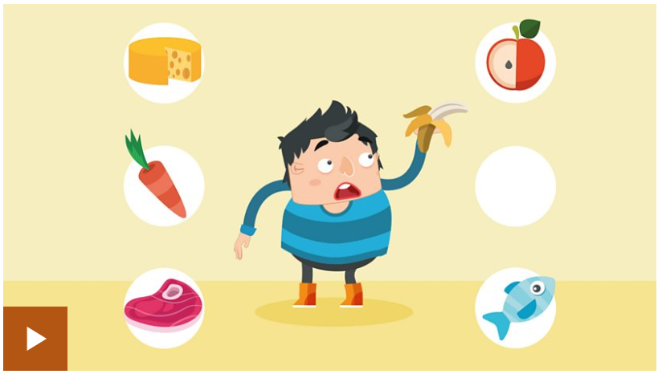 2  3 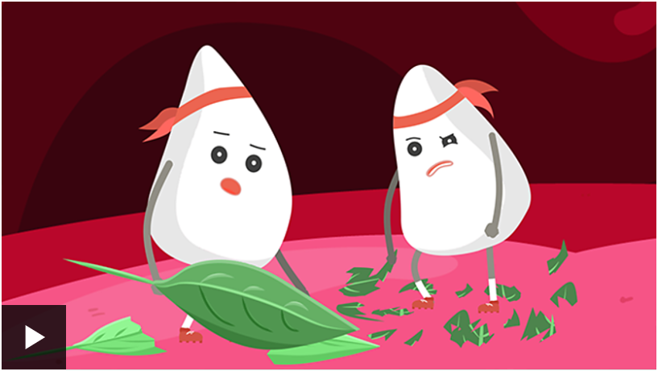  4 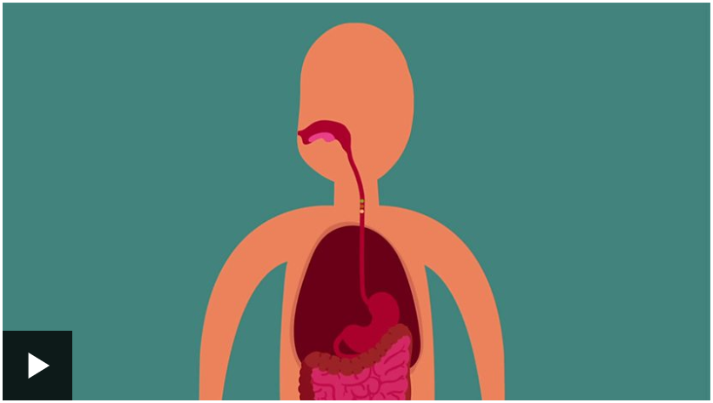 5 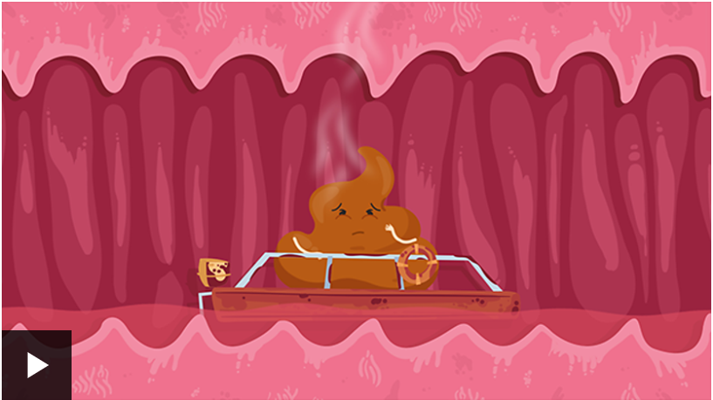 6 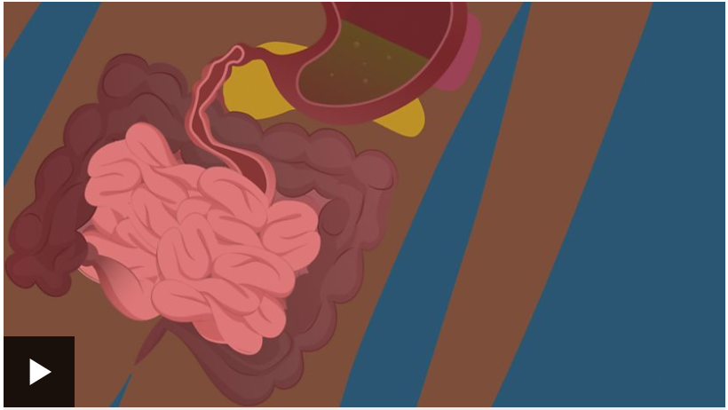 | Activity one  Try to complete the Digestive System Labelling activity – there is a link to download it from the BBC, or directly from our school website.  If you don’t have a printer, could you draw the outline of a human body and try to label it like that? If you are in Year 4 remember how we did this drawing around ourselves on big pieces of paper – you did really well!  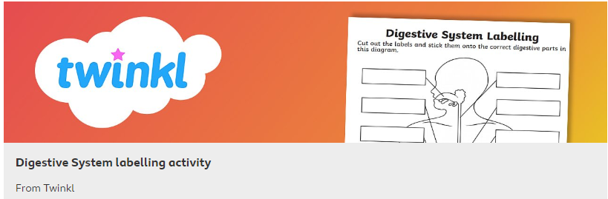
Activity Two  Test out your knowledge by taking the online quiz:  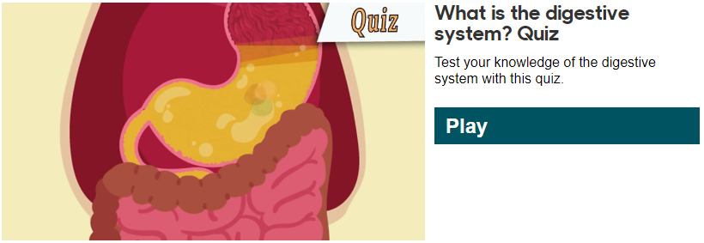 | Activity Three  Think about the food you choose to eat, how healthy is it? Do you eat a balanced diet with lots of fruit and vegetables, some protein like cheeses and meat, and some carbohydrates? Everyone deserves a few treats, but what happens if you eat too many?  Have a look at this video which compares the effect of a healthy breakfast with an unhealthy one – and takes you through a digestion demonstration / experiment that lots of my Year 4s should remember!  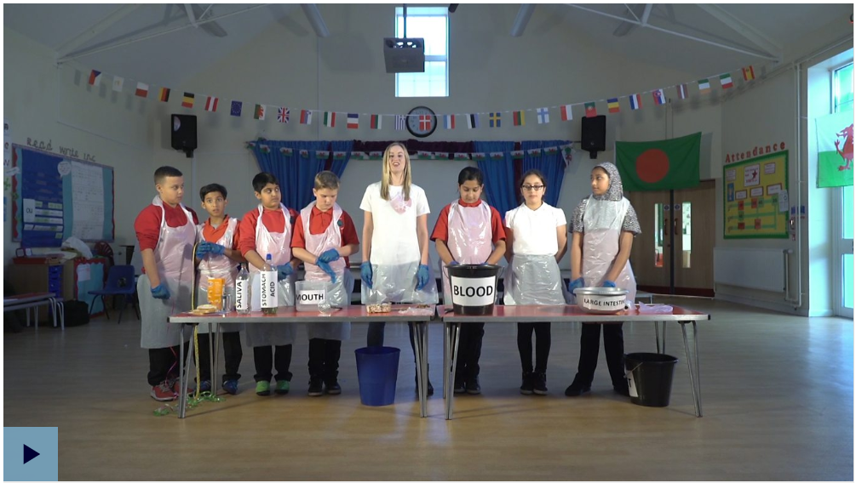  https://www.bbc.co.uk/teach/class-clips-video/science-ks2-digestion-how-breakfast-affects-your-day/zk7rkmn

