Year 3 and 4 Rivers https://www.bbc.co.uk/bitesize/articles/z2kdbqt

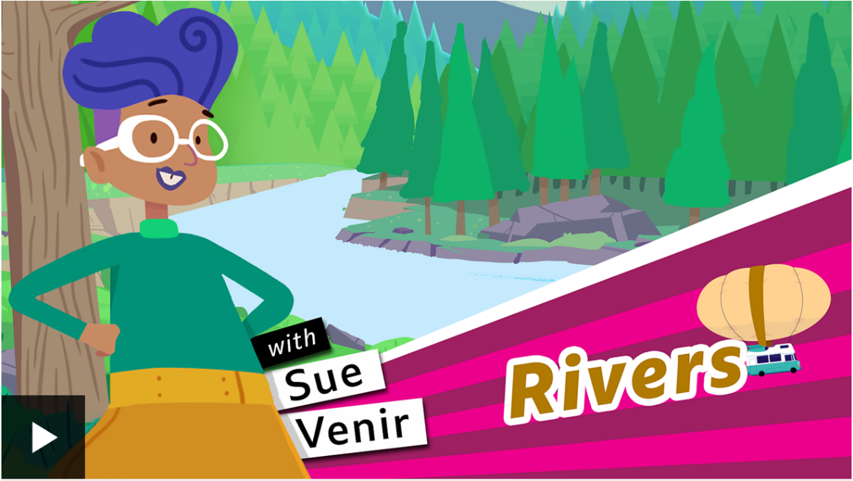  Watch this clip by following the link above | Activity one – Play this quiz from the BBC Bitesize page by following the link above.  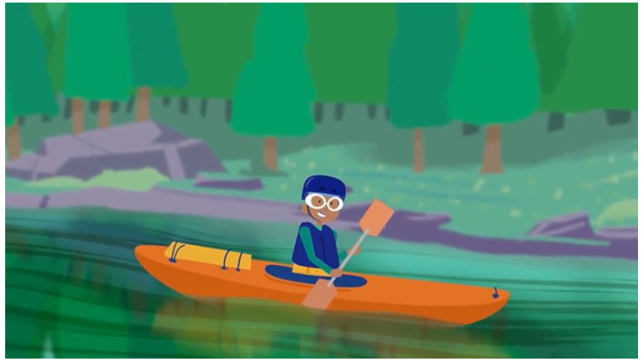
Activity Two  You can find this link on the BBC Bitesize page. It askes you to colour in the rivers on a world map. If you cannot print the map, then you can discuss with an adult the locations of the rivers and discuss which countries they go through.  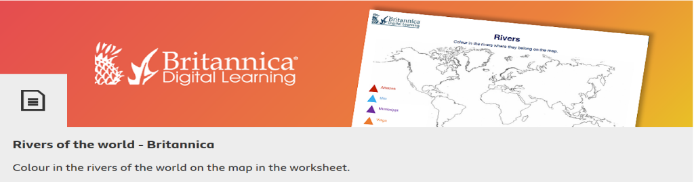 | Activity Three  Complete a fact file for a world river of your choice.  Include these in the fact file:  - Where does the river start? (The source)  - How long is the river?  - Are there any special creatures that live in or near the river?  - Name the countries the river goes through.  - Where is the mouth of the river?  - Can you include a drawing of a river?

