____________________________________________________________

____________________________________________________________
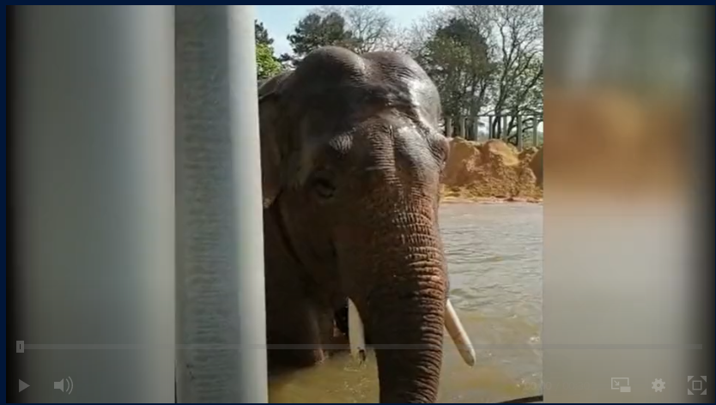It's not just humans who want to stay cool and have fun on one of the UK's hottest days of the year.
Check out called Ming Jung the Asian elephant having a dip in his private pool!
Ming Jung weighs 4300kg and lives at Whipsnade Zoo - the UK's largest zoo - and made the most of the glorious sunshine!
Elephant Team Leader, Stefan Groeneveld said "It's wonderful to see Ming Jung enjoying the pool in this amazing weather; in fact, we're all quite jealous! He uses his trunk as a snorkel while he dives under the water - and flaps his ears to cool himself down."
The zoo is currently closed and relying on donations to help look after the animals.

____________________________________________________________________________________________________________

____________________________________________________________________________________________________________

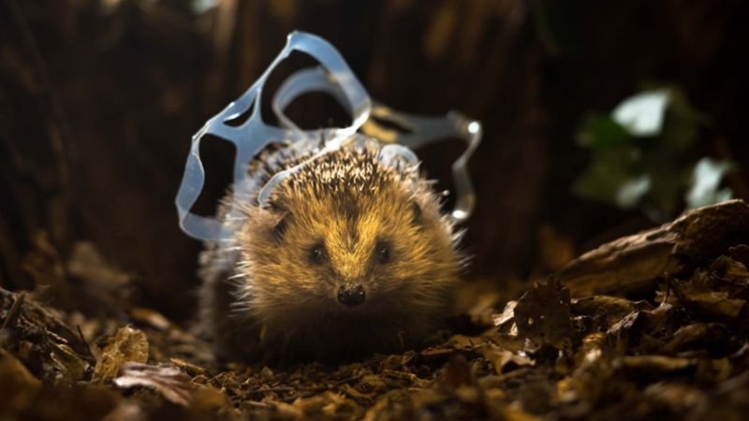CHRIS PACKHAM/PA/KEEP BRITAIN TIDY
This hedgehog was rescued and the plastic was safely removed
The UK's biggest litter charity has told Newsround that millions of animals are dying each year because of littering.
Keep Britain Tidy says we need to make more effort to recycle our bottles and cans because small creatures are getting stuck in them.
Almost 10 billion aluminium cans are produced in the UK each year. But three billion of them aren't recycled properly with many just dropped on the ground.
In a recent study, Keep Britain Tidy estimated that 2.9 million small mammals - like shrews, hedgehogs and voles - are dying each year after getting stuck in bottles and cans thrown onto grassland and parks.
More than two million pieces of litter are dropped in the UK every day, and around 350 million drinks cans are picked up from the ground every year.
Getting rid of litter from the streets costs £1 billion a year, according to research by Keep Britain Tidy.
One person trying to tackle the issue of litter is seven-year-old Elizabeth.
She's been organising monthly litter picks at her local park.

