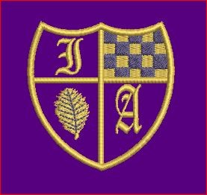 Last Week Activities! 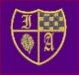
The pictures are web links that will take you through to the activities!
Why is this week different?
This is our last week of school for the year, so to make it a little bit special I thought it might be fun to look at some different sorts of activities – all of which you can find links to online.
What will you learn?
A whole range of things – I have looked around to try to find lots of fun, interesting and exciting activities for you to enjoy!
Learn about the pulse, rhythm and character of music with Florence Price and the Juba Dance!  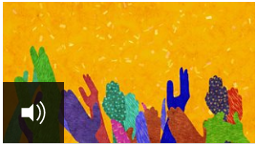  Make up your own rhythmic piece of music using sounds you can make with your own body! | If you have loved our science experiments on sound, check out these experiments and activities to explore further!  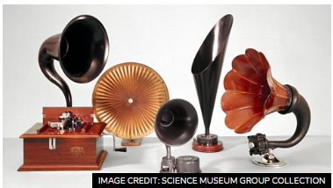  Make an ear gong, go on a sound hunt and investigate loud speakers!
Find out about African and Aboriginal art and the ideas behind line drawing and using symbols!  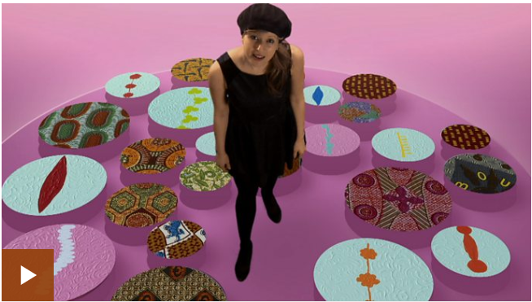  Learn what different colours symbolise, how art is used for communication, why patterns are important and have a go at making your own mask! | Have you ever wondered how the internet works, or how you could use search engines to explore it?  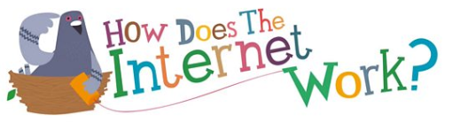  The internet is a big, big place, so it is a good idea to learn how to use it safely: focus on creating the perfect password and find out what your digital footprint means!
Have you enjoyed your Spanish lessons this year? If so, check out some of these activities to extend your language skills!  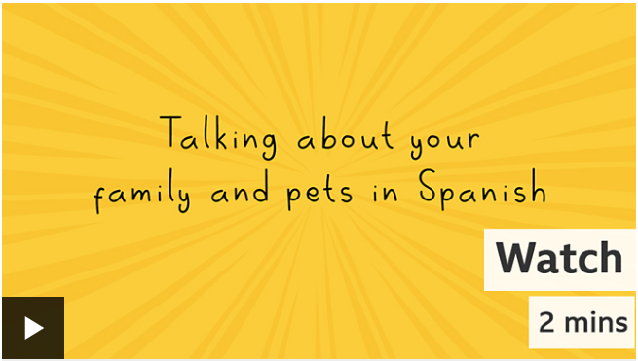  Impress everyone by learning how to describe your family and pets in Spanish! | Remember, we haven’t just learned one language this year, we’ve also been learning how to speak in French!  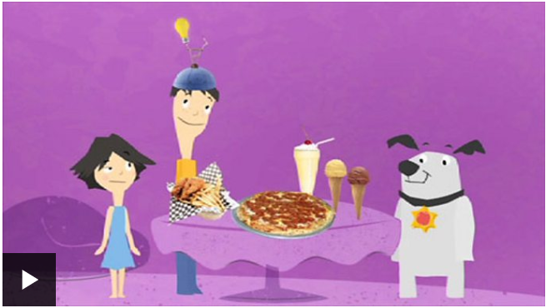  Learn how to talk about the clothes you wear and the food you eat, and if you fancy it check out the recipe to make a delicious crêpe!

