Thursday 23rd April, Year 5

English
Read this news article about Captain Tom Moore’s amazing fundraising activity to support the NHS:
https://www.bbc.co.uk/newsround/52277760

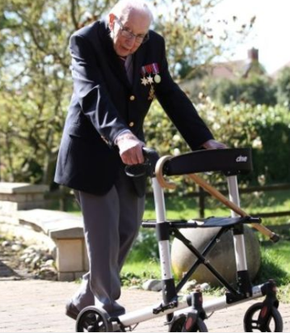

Today’s task is to write a letter to Captain Tom, telling him how inspiring his money-raiser was and to thank him for his efforts. Are there questions you’d like to ask him or other comments you’d like to make?
Remember to begin your letter “Dear Captain Moore”, and finish with “Yours sincerely”.

Use this language:
inspirational | grateful | funds
National Health Service | generosity | respect

Maths
Today we are going to explore factors and prime numbers.

- A prime number is a number that is only divisible by 1 and itself, for example 11.

- A factor is a number which can be multiplied to create another number, for example 4 is a factor of 12.

- Roll your dice to create a 2-digit number. (If you don’t have dice, just think of any 2-digit number).
- Is it a prime number?
- What are the factors?
- Record your work like this….

Number | Prime?  (Yes / No) | Factors
13 | yes | 1,13
24 | no | 1, 2, 3, 4, 6, 8, 12, 24

Extras
Don’t forget to read!
Practise your times tables – look at https://www.timestables.co.uk/games/ and create a free account.
Log onto NumBots and Times Table Rock Stars.

