Friday 24th April, Year 5

English
Read this Rainbow poem…
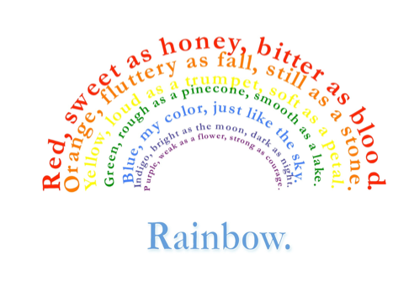
This poem has lots of similes in it (where the poet compares things, using “like” or “as”).
Your task today is to create your own Rainbow poem, using similes and descriptive, poetic language.
Try to present your poem in a colourful rainbow shape like the one above! I’d love to see pictures of your poems – why not send a photo to the school office?


Maths
Toy Shop Maths
 |  | 
Books: £5.25 each | Teddy bear: £12.99 | Football: £6.39
 | 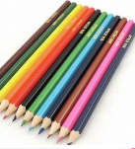 | 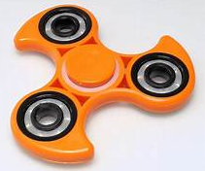
Kite: £10.75 | Pencil pack: £4.50 | Fidget spinner: £3.50

Choose 2 toys. Using the column method, add up the prices to see how much you will spend. Repeat the process, with different combinations of toys, ten times.
Choose 3 toys. Using the column method, add up the prices to see how much you will spend. Repeat the process, with different combinations of toys, ten times.
Choose 4 toys. Using the column method, add up the prices to see how much you will spend. Repeat the process, with different combinations of toys, ten times.
Challenge: how much change will you get from £50?

Extras
Don’t forget to read!
Practise your times tables – look at https://www.timestables.co.uk/games/ and create a free account.
Log onto NumBots and Times Table Rock Stars.

