Monday 27th April, Year 5
Hi, everyone! Hope you are all ok.
This week, we are going to be using more online lessons. During our phone calls, I’ll ask you how you’re getting on with this slightly different way of home learning, and what you think of it!

English

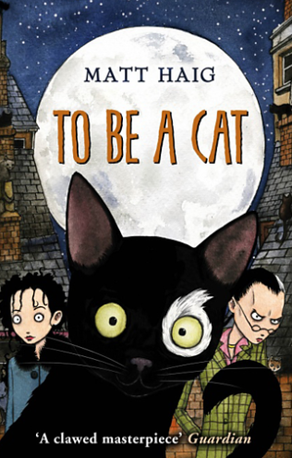

https://www.bbc.co.uk/bitesize/articles/zn8bgwx

Click on the link above and watch the online lesson from BBC Bitesize.
Then, complete the “To Be a Cat” activities from BBC Bitesize in your book.
I’d like you to complete AT LEAST two of the activities, but hopefully you’ll challenge yourself and complete three!
Maths


Click on the link to take you to today’s maths lesson – Lesson 1: adding decimals within 1:

https://whiterosemaths.com/homelearning/year-5/

- Watch the video clip.

- Then, click on “Get the activity”. You can either print off the work (if you have a printer), or just write the answers in your home learning book.

- When you’re done, click on “Get the answers” and check your work. How did you get on?

Extras
Don’t forget to read!
Practise your times tables – look at https://www.timestables.co.uk/games/ and create a free account.
Log onto NumBots and Times Table Rock Stars.

Whole week projects:
History
During our lessons on the topic of chocolate, we discussed the importance of treating the farmers who grow the cacao bean fairly. Do you remember the phrase ‘Fair Trade’?
Please read this passage about Fair Trade and then answer the questions that follow in your home learning book.
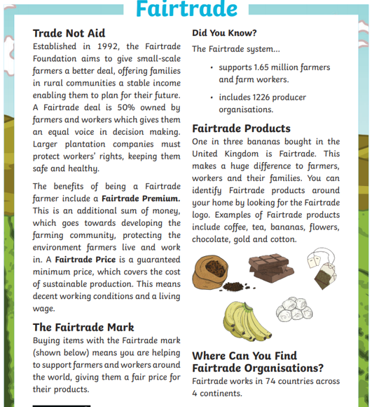

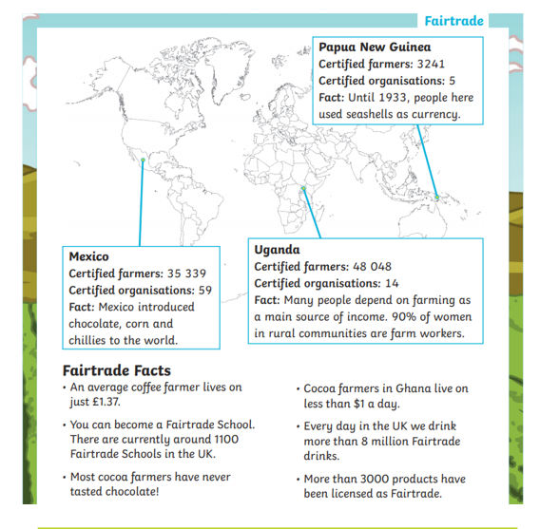
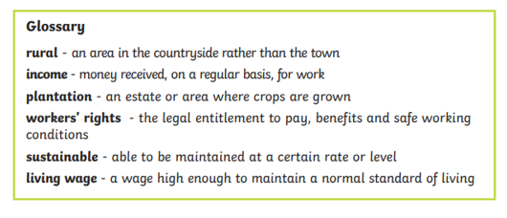
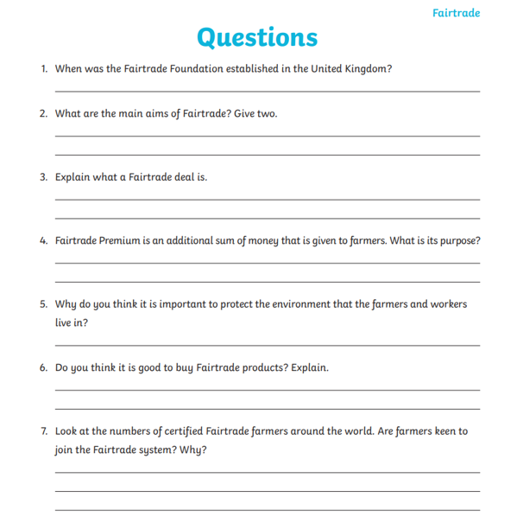Science
- Have a paper aeroplane competition. Research the best design. Whose plane flies the furthest? How can you make this a fair test? Will you repeat the measurements?
- Who can build the best boat? Water pushes upwards with a force called ‘upthrust’. (You can feel this if you try to push a light object such as a balloon under water). The shape of a ‘boat’ affects the weight (passengers/cargo) it can hold. The more water that the boat displaces the more it will float and therefore the more weight it can take.
Using playdough, make different shapes. Put them in water. Which will float? Which will sink?- Try to use the vocabulary to describe forces, for example water resistance, buoyancy, sink, float.
Resources : Plasticine/playdough, Dried peas, Container (e.g. butter carton) of water
Design and make a boat to take the maximum number of passengers with the given materials. For fair testing give each person taking part the same amount of plasticine/playdough.
First roll the plasticine/playdough into a ball and put it into the water. What happens?
How could you get it to float? Once it’s floating, can you get it to take some ‘passengers’ (dried peas)? Can you alter the shape so that the boat will take more ‘passengers’ before it sinks?
Whose boat takes the most ‘passengers’? Why?
Can you use paper, card, a plastic bottle or something else to design a boat? What will you call your boat? Draw and label your design.
Send some photos of your boats to the school office! I’d love to see them!

