Week beginning Monday 1st June
Years 5 and 6 History
History and Geography
We are going to continue with our short project about the Ancient Egyptians.
- Please go to BBC Bitesize and find the History lesson for 11th May: Who was Tutankhamun? You can find this lesson here:
https://www.bbc.co.uk/bitesize/articles/zr2tnrd
- Watch the first video to learn about Tutankhamun, one of Ancient Egypt's most famous pharaohs.
- Please read the information underneath this clip really carefully.
- Watch the second clip to learn how Tutankhamun’s tomb was discovered.
- Now look at the photos and read the information about the other famous pharaohs.
Activities
Now have a go at these activities.

Activity 1:
Can you rearrange the puzzle to make Tutankhamun's mask?

Activity 2
Make, draw or colour in your own Tutankhamun mask. Here is a picture to inspire you!
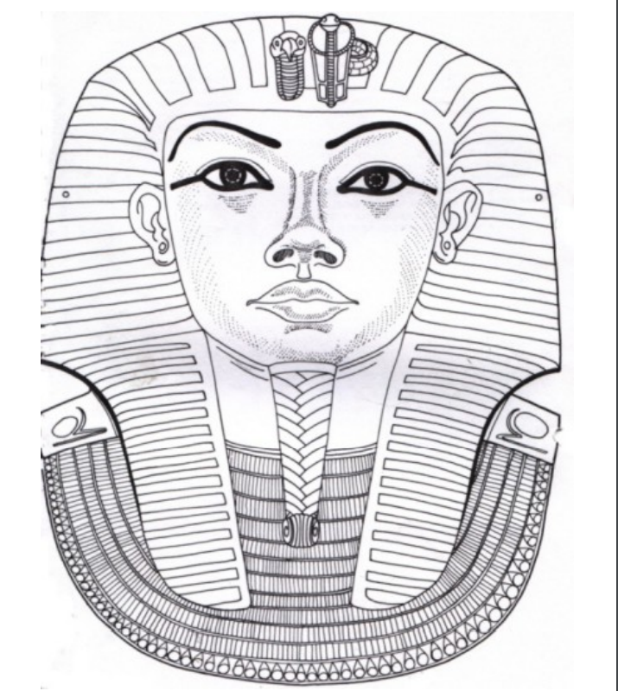

Activity 3: Using the internet, can you research the following pharaohs? Please record the information in your books.


