Week beginning Monday 8th June: Years 5 and 6 Science
Last week we learned about adaptation. Why does a polar bear have white fur? This week we are going to start a new topic about famous scientists and inventors. We are going to think about the life and work of Steven Hawking.
Science
- Now, please go to https://www.youtube.com/watch?v=QiLz-U5cy8g and watch the clip. This is an introduction to the life of Steven Hawking.
- Next, read this biography of him really carefully.

Biography

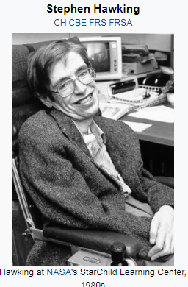

- Occupation: Scientist and astrophysicist
- Born: January 8, 1942 in Oxford, United Kingdom
- Died: March 14, 2018 in Cambridge, United Kingdom
- Best known for: Hawking radiation and the book A Brief History of Time

Early Life
Stephen Hawking was born in Oxford, England on January 8, 1942. He grew up in a highly educated family. Both of his parents had attended Oxford University and his father, Frank, was a medical researcher. Stephen enjoyed maths and science in school where he earned the nickname "Einstein." He wanted to study maths at university but Oxford didn't have a maths degree at the time so he chose physics and chemistry instead. Stephen found college coursework to be very easy. He enjoyed being a member of the school's boat club as well as classical music. After graduation, he went to Cambridge to study for his PhD.
Diagnosed with ALS
While Hawking was working on his PhD at Cambridge University, he began to have health issues. His speech became slurred and he became very clumsy, often dropping items or falling for no reason. After going through a series of tests, doctors discovered that Hawking had a disease called ALS (also called Lou Gehrig's disease). At the time, the doctors said he only had a few years to live.
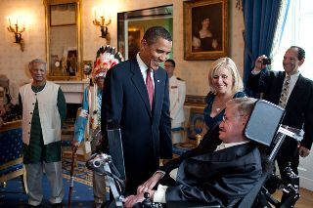
Hawking meeting President Obama by Pete Souza
Overcoming ALS
Although Hawking was initially depressed over his diagnosis, he decided that there were things he wanted to accomplish with his life. He began to study and work harder than ever before. He wanted to earn his PhD before he died. Around the same time, he met and fell in love with a girl named Jane Wilde. Jane was also from St Albans, and was a modern languages undergraduate. She had met Hawking at a New Year’s party, before his diagnosis. The couple decided to marry quickly, because they did not know how long Stephen had to live. As Stephen's health deteriorated, he took to walking with a stick. Jane, who was two years younger than her fiancé, had to seek a special exemption from her college as students were not normally allowed to wed. Between his work and Jane, Hawking had a reason to live.
Despite the initial grim diagnosis from his doctors, Hawking lived a full and productive life with the help of science and modern medicine. Although he was confined to a wheelchair and could not talk for much of his life, he was able to communicate using a touch pad computer and a voice synthesizer.
Black Holes and Hawking Radiation
Stephen spent much of his academic work researching black holes and space-time theories. He wrote many important papers on the subject and became a noted expert on relativity and black holes. Perhaps his most famous theory was one that demonstrated that black holes emit some radiation. Prior to this it was thought that black holes could not get smaller because nothing could escape their enormous gravity. This radiation from black holes has become known as Hawking Radiation.
A Brief History of Time
Stephen also enjoyed writing books. In 1988 he published A Brief History in Time. This book covered modern subjects on cosmology such as the big bang and black holes in terms that could be understood by the average reader. The book became very popular, selling millions of copies and remaining on the London Sunday Times best-seller list for four years. He has since written many more books including A Briefer History in Time, On the Shoulders of Giants and The Universe in a Nutshell.

Hawking celebrated on the silver screen
In ‘The Theory of Everything’, a film made in 2014, Eddie Redmayne gave an Oscar-winning portrayal of Hawking.
The film was based on the book ‘Travelling to Infinity: My Life with Stephen’, by Stephen’s first wife Jane. Jane and Stephen collaborated with the production team, and he allowed his voice to be used on the soundtrack. Hawking himself praised the film and claimed he had trouble distinguishing photographs of his early life from photographs of Redmayne. The film became a lasting testament to Stephen's ability to inspire scientists and the public alike.

An astounding life
In March, Professor Stephen Hawking died. For fifty-five years, he defied a disease that should have killed him in five.
The time spent since his diagnosis was not just about survival – he produced all of his world-changing work. His brilliant theories advanced the ideas of Einstein and ushered Hawking into the pantheon of important modern physicists.

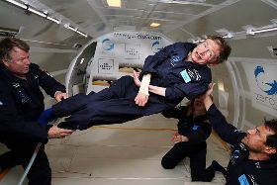
Hawking during a zero gravity test flight
Photo by Jim Campbell

Interesting Facts about Stephen Hawking
- He was born on the 300th anniversary of the death of the famous scientist, Galileo.
- He has been married twice and has three children.
- Stephen has been on several TV shows including The Simpsons and the Big Bang Theory.
- The book A Brief History of Time only has one equation, Einstein's famous E = mc².
- Hawking has co-written several children's books with his daughter Lucy including George's Cosmic Treasure Hunt and George and the Big Bang.
- He received the Presidential Medal of Freedom in 2009.
- He hoped to travel to space one day and trained with NASA on their zero gravity aircraft.
Now, please read the information about his black hole theories really carefully.

- 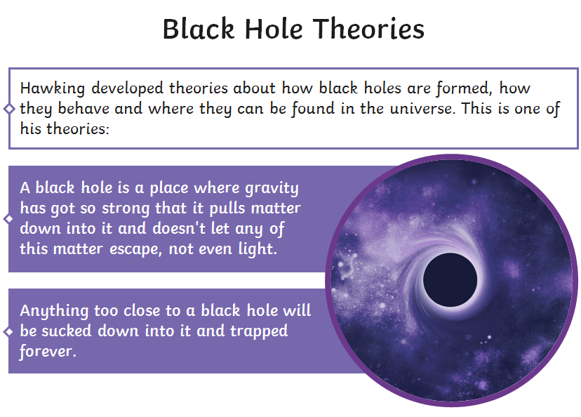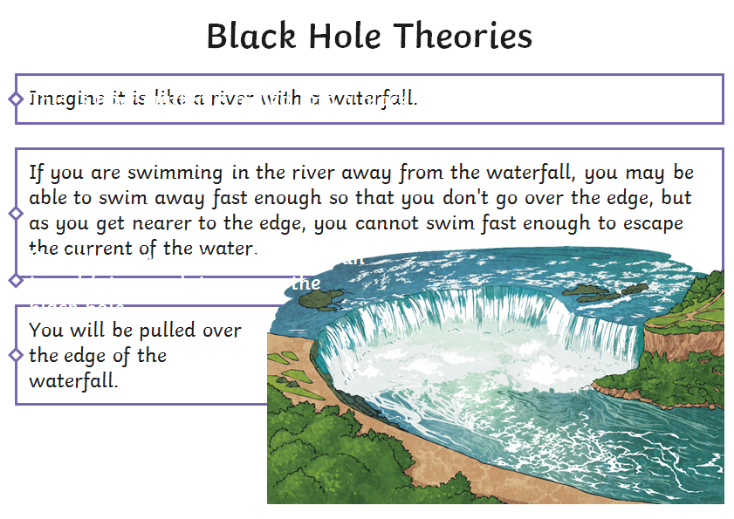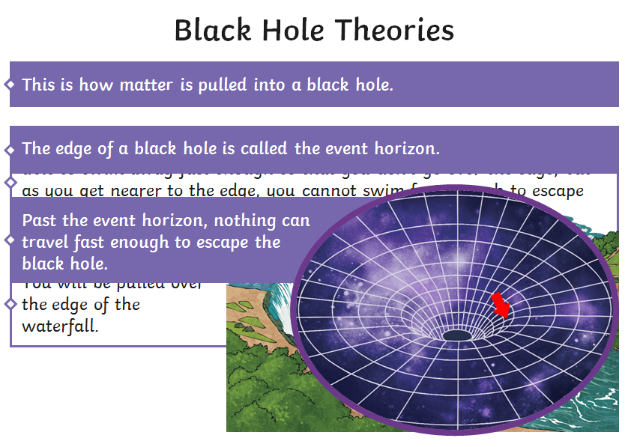
What is a black hole?
Black holes are one of the most mysterious and powerful forces in the universe. A black hole is where gravity has become so strong that nothing around it can escape, not even light. The mass of a black hole is so compact, or dense, that the force of gravity is too strong for even light to escape.
Can we see them?
Black holes are truly invisible. We can't actually see black holes because they don't reflect light. Scientists know they exist by observing light and objects around black holes. Strange things happen around black holes to do with quantum physics and space time. This makes them a popular subject of science fiction stories even though they are very real.
How are they formed?
Black holes are formed when giant stars explode at the end of their lifecycle. This explosion is called a supernova. If the star has enough mass, it will collapse on itself down to a very small size. Due to its small size and enormous mass, the gravity will be so strong it will absorb light and become a black hole. Black holes can grow incredibly huge as they continue to absorb light and mass around them. They can even absorb other stars. Many scientists think that there are super-massive black holes at the center of galaxies.
Event Horizon
There is a special boundary around a black hole called an event horizon. It is at this point that everything, even light, must go toward the black hole. There is no escape once you've crossed the event horizon!
Activities
Now try out your Science skills with these activities. Have a go at activity 1.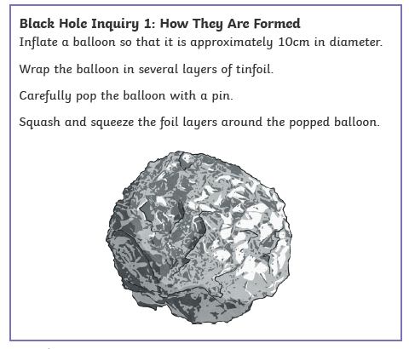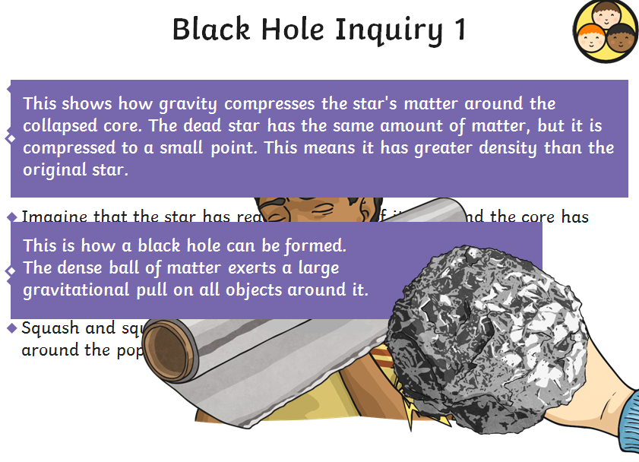Please complete the tasks below in your book.
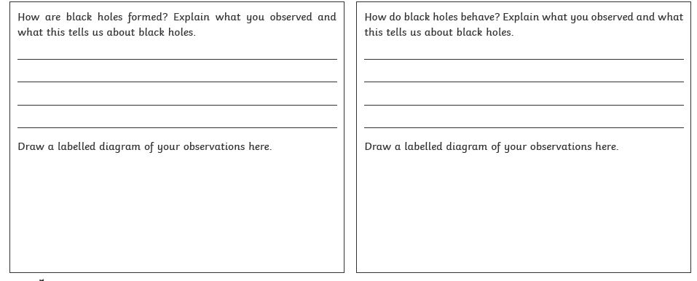
Activity 2 is to design a poster about the life of Steven Hawking and his theories about black holes.

