Week beginning Monday 8th June
Years 5 and 6 History
History and Geography
We have now finished our short project about the Ancient Egyptians. This week, we are going to learn about the life of a famous Tudor king: Henry VIII.
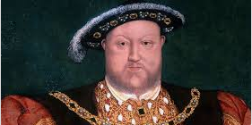
- Please go to BBC Bitesize and find the history lesson for 18th May: Who was King Henry VIII? You can find this lesson here:
https://www.bbc.co.uk/bitesize/articles/z4b8jhv
- Watch the first video to learn about how King Henry VIII changed England forever.
- Please read the information underneath this clip really carefully.
- Watch the second clip to listen to a song about Henry VIII from CBBC Horrible Histories.
- Now watch the third clip to learn about how Henry treated his six wives.

Activities
Now have a go at these activities.

Activity 1: Using information from the guide, make a fact file about King Henry VIII. You could include information about Henry VIII's hobbies, wives, or even the Reformation.

Activity 2
Now play the game to try to put the events of Henry’s life in chronological order.

Activity 3: Use these comprehension sheets to see how much you have learned about King Henry VIII.


