Week beginning Monday 22nd June
Years 5 and 6 History
This week we are going to continue with our short project about the Anglo Saxons. We are going to learn about Anglo-Saxon art and culture.
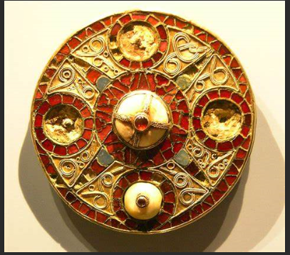

- Please go to BBC Bitesize and find the history lesson for 8th June: Anglo-Saxon art and culture. You can find this lesson here:
https://www.bbc.co.uk/bitesize/articles/zxqkvwx
- Watch the first clip to examine who the Anglo-Saxons were and why they came to Britain.
- Please read the information underneath this clip really carefully.
- Now have a look at the five photographs of pieces of Anglo-Saxon art. Read the information underneath carefully.
- Now watch the next clip to see the story of Beowulf.
- Read the information about the games the Anglo-Saxons played.
Activities
Now have a go at these activities.
Activity 1: Draw your own piece of Anglo-Saxon art or treasure. You can use the images in the lesson today as inspiration for the patterns and colours.

Activity 2: Take the quiz and test your knowledge of Anglo-Saxon art and culture.
Activity 3: Read these slides about Beowulf and then complete the writing activity in your book.


