Week beginning Monday 29th June: Years 5 and 6 Science
Last week we learned about the life and work of Mary Leakey. This week we are going to learn about Daniel Hale Williams. First, please go to https://www.youtube.com/watch?v=j3ObByK7K3E and watch the clip. This is an introduction to the life of Daniel Hale Williams. Next, read these biographical texts really carefully.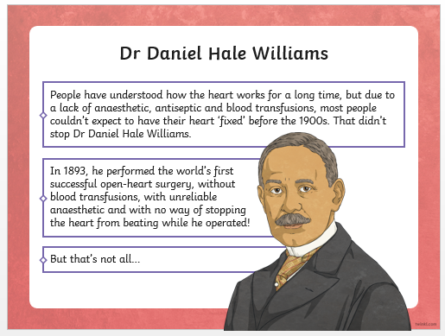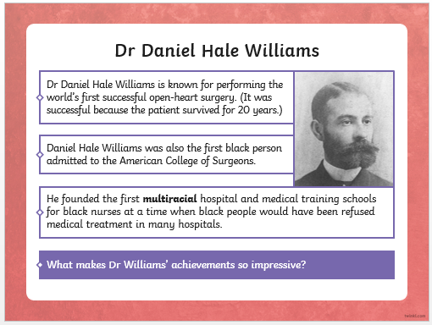
Text 2
Daniel Hale Williams (January 18, 1856 – August 4, 1931) was an American general surgeon, who in 1893 performed the first successful open-heart surgery in the United States to repair a wound. He founded Chicago's Provident Hospital, the first non-segregated hospital in the United States and also founded a nursing school for African Americans.
The heart surgery at Provident, which his patient survived for the next twenty years, is referred to as "the first successful heart surgery" by Encyclopedia Britannica. In 1913, Williams was elected as the only African-American charter member of the American College of Surgeons.

Career
When Daniel Hale Williams graduated from what is today Northwestern University Medical School, he opened a private practice where his patients were white and black. Black doctors, however, were not allowed to work in American hospitals. As a result, in 1891, Williams founded the Provident Hospital and training school for nurses in Chicago. This was established mostly for the benefit of African-American residents, to increase their accessibility to health care, but its staff and patients were integrated from the start.
In 1893, Williams became the first African American on record to have successfully performed open-heart surgery to repair a wound. On July 10, 1893, Williams repaired the torn pericardium of a knife-wound patient, James Cornish. Cornish, who was stabbed directly through the left fifth costal cartilage, had been admitted the previous night. Williams decided to operate the next morning in response to continued bleeding, cough and "pronounced" symptoms of shock. He performed this surgery, without the benefit of penicillin or blood transfusion, at Provident Hospital, Chicago. About fifty days after the initial procedure, Cornish left the hospital.^{[8]}
In 1893, Williams was appointed surgeon-in-chief of Freedman's Hospital in Washington, D.C., a post he held until 1898. That year he married Alice Johnson, who was born in the city and graduated from Howard University, and moved back to Chicago. In addition to organizing Provident Hospital, Williams also established a training school for African-American nurses at the facility. In 1897, he was appointed to the Illinois Department of Public Health, where he worked to raise medical and hospital standards.
Williams was a Professor of Clinical Surgery at Meharry Medical College in Nashville, Tennessee, and was an attending surgeon at Cook County Hospital in Chicago. He worked to create more hospitals that admitted African Americans. In 1895 he co-founded the National Medical Association for African-American doctors, and in 1913 he became a charter member and the only African-American doctor in the American College of Surgeons. However, he died in relative obscurity. His retirement home was in Idlewild, Michigan, a black community.^{[14]:269}

Personal life
Daniel Hale Williams was born in 1856 and raised in the city of Hollidaysburg, Pennsylvania. His father, Daniel Hale Williams Jr., was the son of a Scots-Irish woman and a black barber. His mother was African American and likely also mixed race.
The fifth child born, Williams lived with his parents, a brother and five sisters. His family eventually moved to Annapolis, Maryland. Shortly afterwards, when Williams was nine, his father died of tuberculosis. Williams' mother realised she could not manage the entire family and sent some of the children to live with relatives. Williams was apprenticed to a shoemaker in Baltimore, Maryland but ran away to join his mother, who had moved to Rockford, Illinois. He later moved to Edgerton, Wisconsin, where he joined his sister and opened his own barber shop. After moving to nearby Janesville, Wisconsin, Williams became fascinated by the work of a local physician and decided to follow his path.
He began working as an apprentice to Dr. Henry W. Palmer, studying with him for two years. In 1880, Williams entered Chicago Medical College, now known as Northwestern University Medical School. After graduation from Northwestern in 1883, he opened his own medical office in Chicago, Illinois.
Williams was married in 1898 to Alice Johnson, natural daughter of American sculptor Moses Jacob Ezekiel and a mixed-race maid. Williams died of a stroke in Idlewild, Michigan on August 4, 1931. His wife, Alice Johnson, had died in 1924.

Honours
Williams received honorary degrees from Howard and Wilberforce Universities, was named a charter member of the American College of Surgeons, and was a member of the Chicago Surgical Society.
A Pennsylvania State Historical Marker was placed at U.S. Route 22 to commemorate his accomplishments and mark his boyhood home.

Activities
Now try out your Science skills with these activities. Have a go at activity 1. Please record the answers in your books.

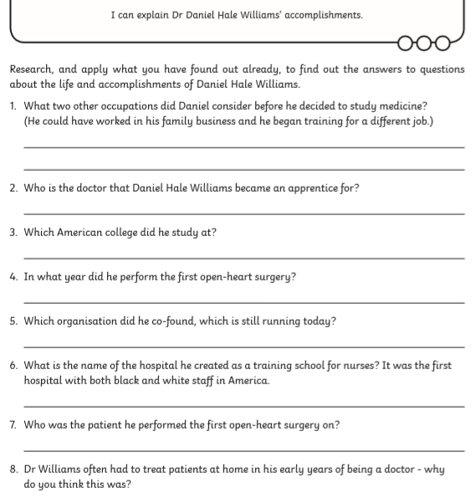

Now try activity 2. Can you draw and label this diagram of the heart in your book? When you have finished, you can check your answers on the following page.



