Week beginning Monday 6th July
Year 5 and 6 Geography
This week we are going to think about the American state of Florida.
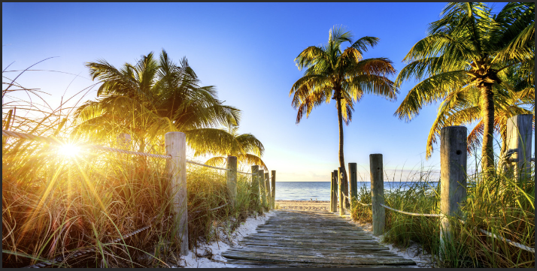
- Please go to BBC Bitesize and find the Geography lesson for 23rd June: Florida. You can find this lesson here:
https://www.bbc.co.uk/bitesize/articles/zvybp4j
- Watch the first clip to explore the state of Florida.
- Read the information about Florida really carefully.
- Look carefully at the photographs of Florida.

Activities
Now have a go at these activities.
Activity 1: How much have you learnt about Florida? Test your knowledge with this five question multiple choice quiz.
Activity 2: Using what you've learnt in this lesson, what aspects of Florida would be of interest to different people? Draw out the following activity sheet in your book and fill it in.
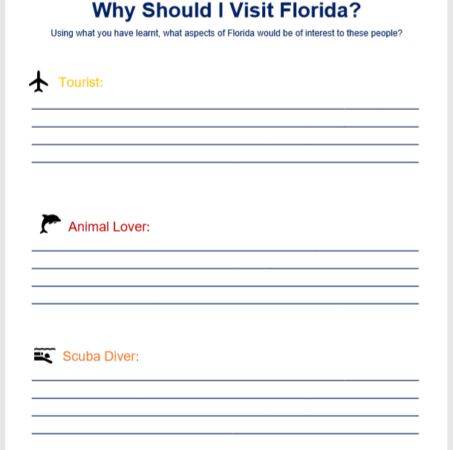
Activity 3: In this lesson you've learnt about some of the animals you can find in the Everglades in Florida. Use a search engine to find out more about these animals and create an animal fact file about one of them. Draw out the activity sheet below in your book and complete it.



