Week beginning Monday 6th July
Years 5 and 6 History
This week we are going to learn about the kingdom of Benin.
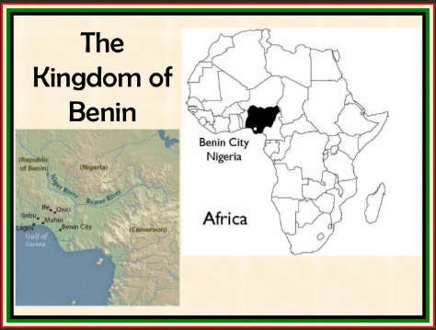
- Please go to BBC Bitesize and find the history lesson for 22nd June: The kingdom of Benin. You can find this lesson here:
https://www.bbc.co.uk/bitesize/articles/zgkwr2p
- Watch the first clip to learn about the Benin civilisation.
- Please read the information underneath this clip really carefully.
- Now listen to the account of what the merchants saw on their travels in Benin.
- Read the information underneath about how the civilisation came to an end really carefully.
Activities
Now have a go at these activities.
Activity 1: Create a keyword glossary for the Kingdom of Benin. You could include:
- Oba
- Edo people
- empire
Activity 2: Draw and complete the research map to show what you have learnt about the kingdom of Benin.


