Week beginning Monday 13th July
Year 5 and 6 Geography
This week we are going to think about an area of outstanding beauty in the United Kingdom: the Lake District.
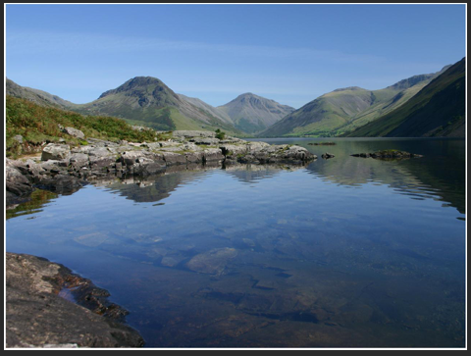
- Please go to BBC Bitesize and find the Geography lesson for 16th June: the Lake District. You can find this lesson here: https://www.bbc.co.uk/bitesize/articles/zd49ydm
- Watch the first clip to see an introduction to the Lake District.
- Read the information about the Lake District really carefully.
- Look carefully at the photographs of the Lake District.
Activities
Now have a go at these activities.
Activity 1: How much have you learnt about the Lake District? Test your knowledge with this quiz.
Activity 2: Using what you've learnt in this lesson, as well as the following information, make a mind map about the Lake District.


