This lesson is in the section for students in Year 7.
Week beginning Monday 13th July
Years 5 and 6 History
This week we are going to learn about the Islamic world in the Middle Ages.
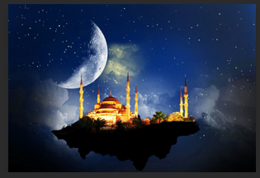
- Please go to BBC Bitesize and find the lessons for students in Year 7. Then find the history lesson for 8th June: The Islamic world in the Middle Ages. You can find this lesson here:
https://www.bbc.co.uk/bitesize/articles/zd7dbqt
- Watch the first clip to learn more about Baghdad and the Islamic golden age.
- Please read the information underneath this clip really carefully.
- Now watch the second clip to learn more about early Islamic inventions.
- Read the information underneath really carefully.
- Watch the third clip to learn more about early Islamic food.
- Watch the short film to find out more about the construction of Baghdad and how it looked in 900AD.
Activities
Now have a go at these activities.
Activity 1: Create a poster about the Islamic world in the Middle Ages. You could include:
- scientific developments
- medicine in the Islamic world
- everyday life in Baghdad
Activity 2: Test your knowledge of the Islamic world in the Middle Ages with the quiz on Bitesize.



