Tuesday 24th March, Year 6
If you did not receive your home learning pack last week, please collect it from the school office as soon as possible.
English
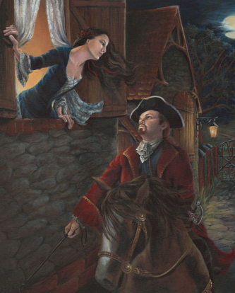

We have been studying “The Highwayman” by Alfred Noyes. You can remind yourself of the poem here: https://www.youtube.com/watch?v=eLbfPsdlymg
Look at the picture of the Highwayman and Bess. What are they talking about? Imagine their conversation. Are they planning to run away together or meet again in secret? Write your imagined conversation as a play script.
This week’s spellings:
official• special• artificial• social• racial• crucial• facial• beneficial• superficial• antisocial
Write these words in sentences in your home learning book.
Maths
Watch this clip. It will remind you how to round numbers.
https://www.youtube.com/watch?v=47lajakFQlQ
Now turn to the first six pages in your home learning pack from Classroom Secrets. Spend 30 minutes working through them. You can do them on the sheets or in your book. You will all finish a different number of sheets, and that is fine.
If you don’t have your home learning pack yet, please use this link. You can download the worksheets so that you can see them on the screen, and do them in your book.
https://classroomsecrets.co.uk/free-home-learning-packs/
Once you have finished, please ask someone at home to mark your work for you, using the answers from the answer pack. (The answer booklet is also available if you follow the link above.)

Extras
- Don’t forget to read your book!
- Practise your times tables – look at https://www.timestables.co.uk/games/ and create a free account.
- Log onto NumBots and Times Table Rock Stars.
- Joe Wicks will be launching PE lessons on his YouTube channel every day at 9am. Try to take part in his PE lessons. www.youtube.com/channel/UCAxW1XT0iEJo0TYlRfn6rYQ

Whole week projects:
History
Watch these video clips about life in Mayan times:
https://www.youtube.com/watch?v=iaKofHyZ00c
https://www.bbc.co.uk/teach/class-clips-video/introducing-the-maya-civilisation/znk3cqt
Task:
Create a mini fact-file / information text about the Mayans – you can also do your own extra research on the internet, if you are able.
You will need:
- A title
- An introductory paragraph
- Subheadings
- Key facts (Make notes as you’re watching the videos!)
- To write in full sentences.
You could illustrate your work with Mayan art work, if you like!
Science
- Watch the following clip about electricity. While you watch, take notes. https://www.youtube.com/watch?v=Uf76pThNXZc
- Use your notes to create a poster all about electricity. How is electricity measured? What are the different types of electricity? What are the safety rules for using electricity?

