Friday 27th March, Year 6
News from Mrs Gogarty: I had a chat with some of you today. Basit said he’d been playing lots of football in his garden. How is everyone else passing the time? Well done for making such a good start with the home learning!
English
In our poetry work, we have been looking at onomatopoeia. Remind yourself about onomatopoeia here:
https://www.bbc.co.uk/bitesize/topics/z4mmn39/articles/z8t3g82
Read this poem:
Crackle! Spit!
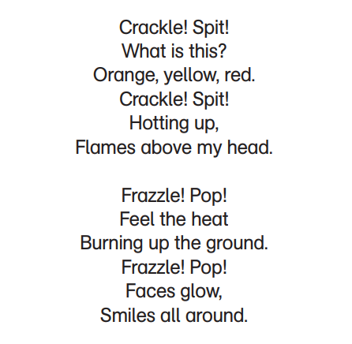 | 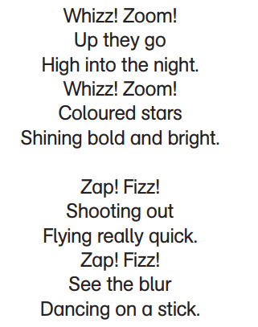

What do you think the poem is about?
Make a list of the words with onomatopoeia.
Write your own poem that contains words with onomatopoeia.
Possible themes / titles: Bath Time, The Dustbin Lorry, The Orchestra, The Rock Band, The Football Crowd

Maths
Watch this clip. It will remind you how to read and plot coordinates in the four quadrants.
https://www.youtube.com/watch?v=9iRGi_bdaXo
Now turn to the next six pages in your home learning pack from Classroom Secrets on the four quadrants. Spend 30 minutes working through them. (You can spend longer if you like.) You can do them on the sheets or in your book. You will all finish a different number of sheets, and that is fine.
If you don’t have your home learning pack yet, please use this link. You can download the worksheets so that you can see them on the screen, and do them in your book.
https://classroomsecrets.co.uk/free-home-learning-packs/
Once you have finished, please ask someone at home to mark your work for you, using the answers from the answer pack. (The answer booklet is also available if you follow the link above.)
Extras
Don’t forget to read!
Practise your times tables – look at https://www.timestables.co.uk/games/ and create a free account.
Log onto NumBots and Times Table Rock Stars.

