Week beginning Monday 15th June: Years 5 and 6 Science
Last week we learned about the life and work of Steven Hawking. This week we are going to learn about Steve Jobs.
Science
- First, please go to https://www.youtube.com/watch?v=cPcXMpjyZiI and watch the clip. This is an introduction to the life of Steve Jobs.
- Next, read this biography of him really carefully.

Biography of Steve Jobs



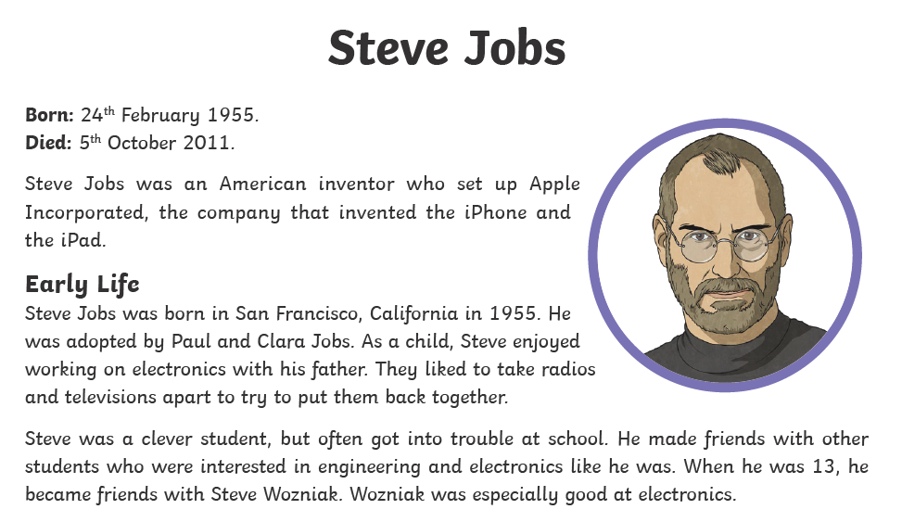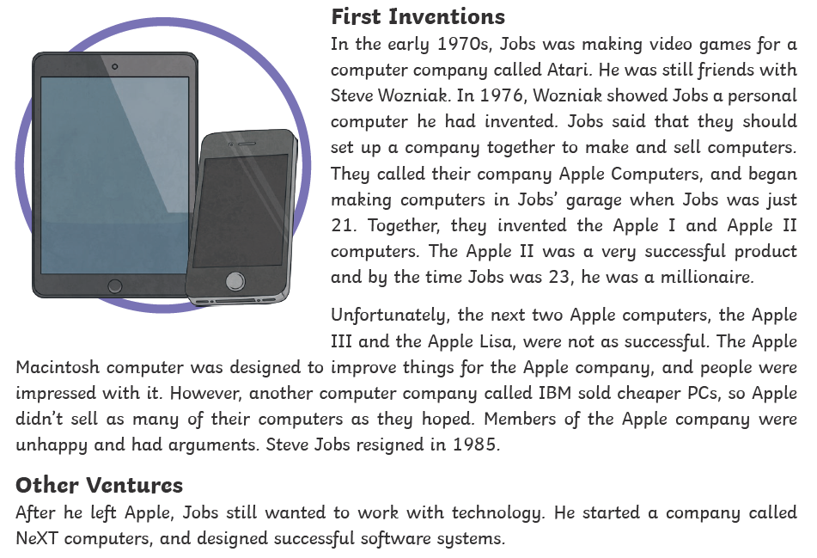

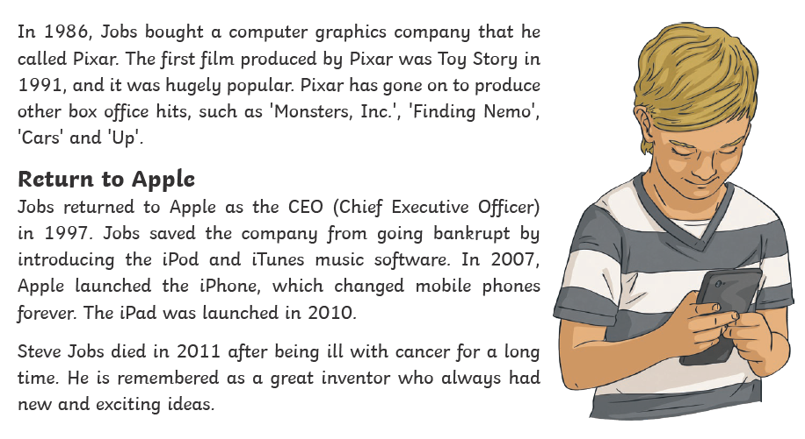
Activities
Now try out your Science skills with these activities. Have a go at activity 1. Complete these comprehension questions about Steve Jobs. Please record them in your book.

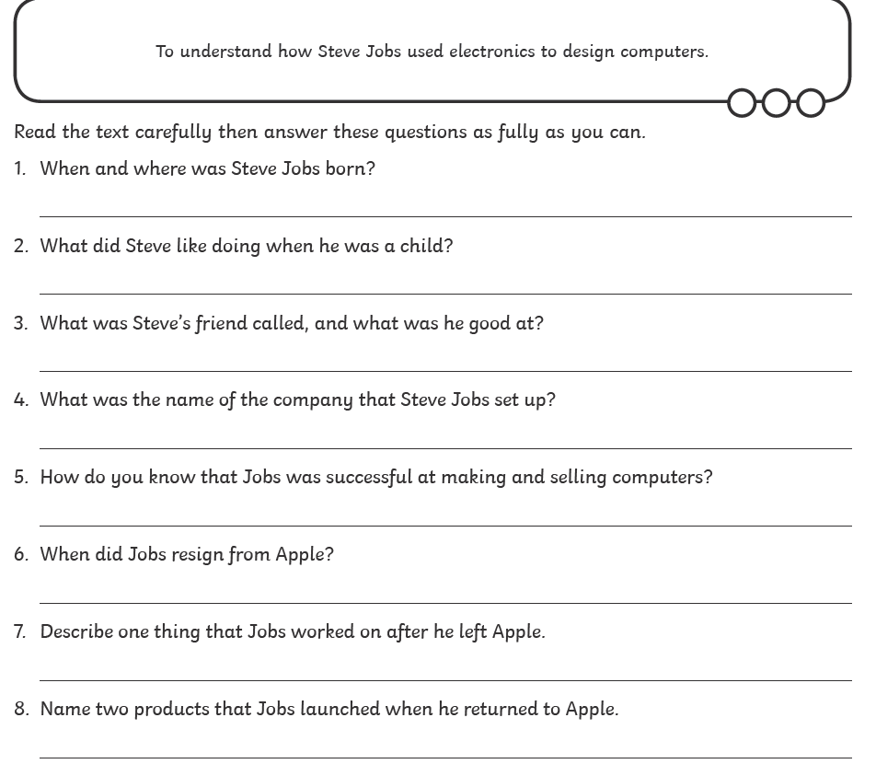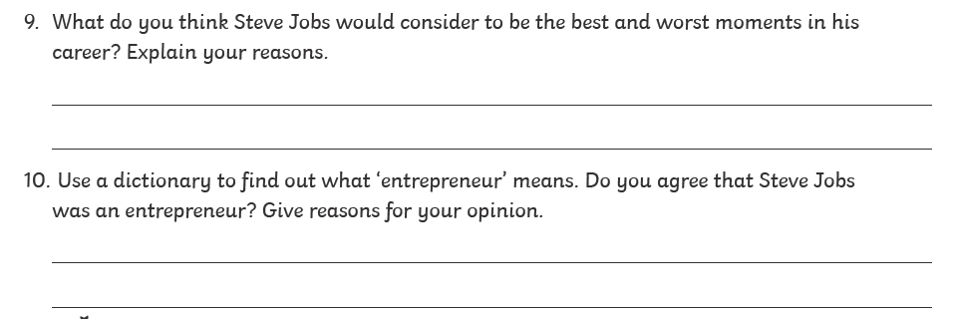

Electrical components are used in computers. Activity 2 is to draw and label this electrical circuit in your book.


