EYFS Topic Home Learning
Topic: Animals and Minibeasts
We will learn about: |  | Life cycles of a frog and a caterpillar
Words we can use: |  | Frogspawn, tadpole, froglet, frog, egg, larva, caterpillar, pupa, chrysalis, butterfly, change, grow, develop.
Questions we can ask: |  | What does frog spawn look like? Where do frogs live? Can they live underwater? Where is a good place to lay a caterpillar egg? How long does a caterpillar take to turn into a butterfly? How long does a butterfly live? What does it eat?
Activity: |  | Cosmic Kids Hungry Caterpillar Yoga  https://www.youtube.com/watch?v=xhWDiQRrC1Y  Talk about when you were a baby, what can babies do? What can you do now you could not do when you were a baby? What will you be able to do when you are older and bigger? Look at photos and videos of you when you were little and talk about how you’ve changed.
Stories: | The Very Hungry Caterpillar  https://www.youtube.com/watch?v=75NQK-Sm1YY  The Frog Song  https://www.youtube.com/watch?v=QjYkG8jDsJU
Things you could do:
Find out about the life cycle of a frog and a butterfly.
https://www.youtube.com/watch?v=gmlaclb3K2o https://www.youtube.com/watch?v=jivWeOrCaeI

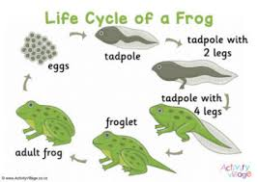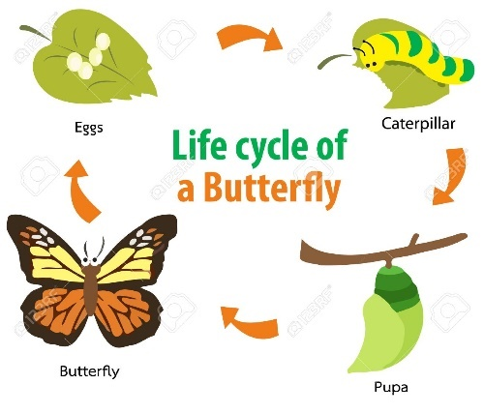

Caterpillar craft.


