
EYFS Topic Home Learning

Topic: Amazing Animals Land & Sea
We will learn about: |  | Wild animals
Words we can use: |  | Polar bear, wolverine, penguin, seal, Artic, Antarctic, north pole, south pole, artic fox.
Questions we can ask: |  | What do animals need to keep warm in the cold and snow? What do we need when it is cold? What makes ice melt? How do things freeze?
Activity: |  | https://www.youtube.com/watch?v=_kA-_aro3lI Explore the Artic  https://www.youtube.com/watch?v=lAJB-dKTAQM Penguin facts
Stories: | https://www.youtube.com/watch?v=ehoGdGokXfc Polar Bear, Polar Bear  https://www.youtube.com/watch?v=CAIwd_Uemqs Little Polar Bear
Things you could do:
https://www.messforless.net/10-ice-play-activities/ Lots of great ideas for playing and experimenting with ice.

Ice Skating Penguins Fill gloves with water and freeze Make your own ice painters
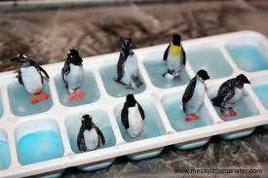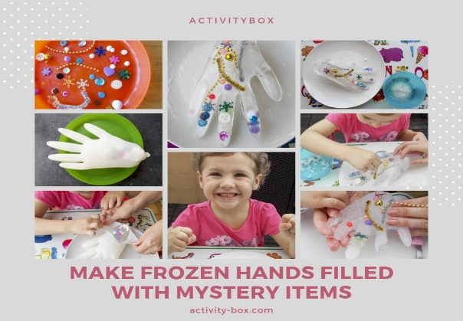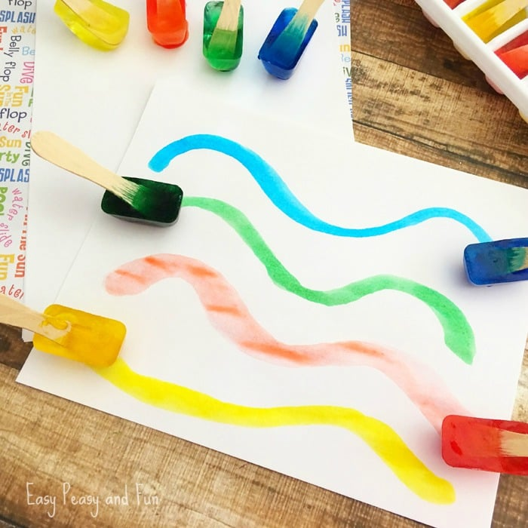

Here are some yoga sessions you might like…
https://www.youtube.com/watch?v=jSZvMHlw9vs&vl=en-GB Join Pedro the penguin near the South Pole and learn all about persistence
https://www.youtube.com/watch?v=DP9jd1Ug2y4 Joybob the Polar bear will teach you all about spreading joy from his home in the North pole.

Bring the noise… Listen to a rap about the top and bottom of the world and the animals that live in these very cold places. Maybe you could make up your own rap about p p p p penguins?
https://www.bbc.co.uk/teach/bring-the-noise/andys-raps-polar-party/zn9fmfr/

As always, we love to see photos of you playing, experimenting and learning, please send any photos to eyfs@ivingswoodacademy.org

