
Ivingswood Academy

Returning to School September 2020

Information for Parents

July 2020 – subject to change dependent on updated DfE guidance

Dear parents/carers,
It is our intention at this time to adhere to the Department of Education’s guidance for schools to open fully to all children in September. Please spend time reading this important information which is designed to inform you of the many measures we are taking to keep children and staff as safe as possible and ensure that you are confident and clear with the expectations for you and your child.
Before the start of school in September, a review of our comprehensive plan will take place, with the view that the guidance may change between now and September. I will ensure all staff are trained, the risk assessment is implemented and that all physical changes to the school are in place. Red Kite Schools Trust will review this work and decide if our school is as safe as it can be in order to welcome all children and staff back to school.
I understand that you may have information about the information enclosed. Please email me with any questions you may have: office@ivingswoodacademy.org
Please be assured that, whilst some of the information below may appear startling, your child will still be welcomed back by the warm and loving faces of the Ivingswood staff. They will be cared for, looked after and supported to adjust to the new ways of learning. A special presentation for children will be created and sent to you before the start of school.
I look forward to seeing you all in September.
Kind regards,

Julie-Ann Swaysland
Headteacher

Should my child come to school?
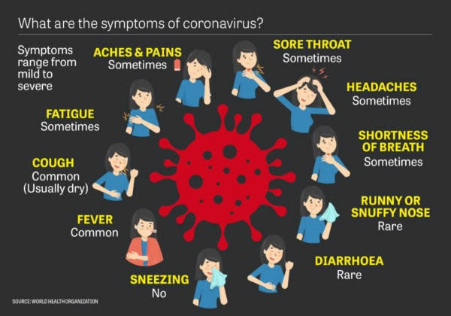
- All children are now expected to return to school with a risk of fining for those who do not.
- Please ensure your child is well enough to attend school. If in doubt, call us before bringing your child to school.
- You must not come to school if your child is displaying any Covid-19 symptoms.

What will you do if my child shows symptoms in school?
- Your child will be asked to go to a separate room and will be cared for, at social distance, by an adult.
- If your child requires first aid, the adult will wear personal protective equipment (PPE). They will explain this to your child and talk to them throughout.
- We will call you and ask you to collect your child immediately.
- You will be required to get them tested for coronavirus and to share the results with us as a matter of urgency. All parents will be required to agree to this via parent permissions which will be sent out in late August.
What if there is a confirmed case of Coronavirus in school?
- You must inform us if your child tests positive for Coronavirus.
- In this circumstance:
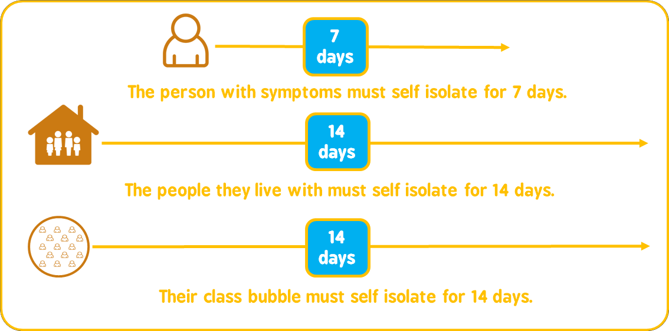
How will you guarantee social distancing?
The Government have made it clear that ‘early years and primary age children cannot be expected to remain 2 metres apart from each other and staff’ and, as such, we are unable to guarantee this social distancing requirement to you.
Nevertheless, significant measures have been put in place to promote social distancing including:
- Children remaining in consistent class and phase (2 classes) bubbles;
- Zoned and time allocated play spaces;
- Children seated facing forward in the same space every day (From Year 2);
- Lunches in classrooms;
- Soft start and use of the external classroom doors;
- Staggered finishing times;
- Limited shared resources and individual resource packs provided;
- Strictly limited internal movement within the school for the children and staff;
- No large gatherings such as assemblies.
What can my child wear?
- All children are to return to school in either:
  - Their usual school uniform most days of the week
  - Their school PE kit on their PE days. Your teacher will inform you of these days in the first week back.
- Please ensure where possible your child wears clean clothes each day. There is no need for any type of special clearing of clothes – a normal wash is suitable.
- Face masks cannot be worn in school as they may not handle them correctly which can lead to an increased risk of transmission.
- Children will be spending more time outside. Please ensure they have sun lotion applied and a sun hat during hot weather. On rainy days, they will need a raincoat and a change of shoes for outside (old trainers, boots, wellies will all be fine). Children in Early Years should bring in a pair of wellington boots.
What if my child doesn’t follow the school’s rules?
- Our usual school approach of promoting positive behaviour through our rules and values will continue as normal upon your child’s return. However, an addendum to our Behaviour Policy has been produced and can be found at the back of this booklet.

How can I support my child?
Many of our children will not have been to school for a long time and may be nervous about the thought of returning. We know that you will want to support your child to return to school in the best way that they can. Below are some tips to support this. Please don’t hesitate to call us if you need help or support.
Our school website also has some useful resources which can help children. You can find them under the ‘School Closure’ tab.
Above all, it is important to reassure your child that school is a safe place: we have lots of cleaning and hygiene precautions in place to make sure that this is the case.

Talk with your child about how pleased the grown-ups in school will be to see them.


Speak positively and calmly about the return to school and the behaviours that will be expect of them. Validate your child’s feeling – “It’s ok to feel like that.”


Make sure your child goes to bed early and wakes up in time to get ready for school. Try to get into this routine a few weeks before school starts.

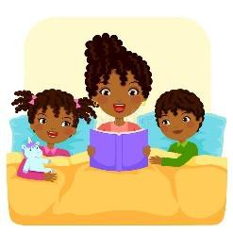
Listen and learn. Begin to limit screen time if they have been spending more time on devices. Read stories with your child and ask them questions about what they have read.

Teach them how to wash their hands effectively for 20 seconds. There are lots of videos that can help with this – and give them songs to sing to help remember the time.
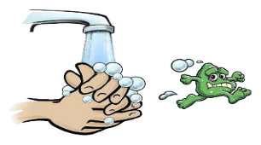

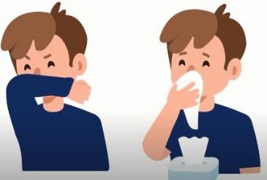
Remind them to cough and sneeze into their elbow or a tissue if they have one. Remember: ‘Catch it, Bin it, Kill it’


Encourage them to ask questions about the return to school. Let them know that it is okay not to know the answer or to be worried. The grown-ups in school will be able to help them – they just have to ask.

The School Day
The school day will run almost as it has previously however, we have made a few slight changes to allow for social distancing and keeping bubbles apart.
Start of the day
- Instead of a staggered arrival, there will be a ‘soft start’. Children should arrive at school between 8.30am and 8.50am and go straight to their classrooms via the external doors. All children must be in school by 8.50am
- After the first day, children in Years 3 – 6 will be encouraged to leave their parents at the gate and enter school on their own.
Lunch time
- Lunches will be eaten in classrooms at the start of the year. A packed lunch will be available from school or children may bring their own lunches.
- After eating, children will have allocated outside playtime with one other class, part of their ‘phase bubble’.
- Lunchtimes will be staggered by phases:
  - Early Years: 12.30pm – 1.20pm
  - Years 1 and 2: 12.30pm – 1.20pm
  - Years 3 and 4: 12.00pm – 12.50pm
  - Years 5 and 6: 12.15pm – 1.05pm

End of the day
- To allow for social distancing, finishing times will staggered:
  - Reception class: 3.15pm
  - Years 1 and 2: 3.25pm
  - Years 3 and 4: 3.20pm
  - Years 5 and 6: 3.30pm
- Children will exit classroom via the external classroom doors.
- Years 1 and 2 should be collected from the playground, not the classroom to allow for social distancing.
- Parents waiting for children in more than one year group are encouraged to wait on the playground or pathways, taking notice of the social distancing markings.
- Children in Years 5 and 6 are encouraged to leave school on their own and meet parents outside of the school gates.
Wrap around care
- Subject to staffing, breakfast club will be available from 8am. Children will sit in Year groups and will not be allowed to use the games.
- After school care will still be available in the drama room until 3.45. Children will again sit in year group tables.
Arriving at school

Hand sanitiser dispensers will be available inside each classroom door.



Children must use immediately on entry to their classroom.

Arriving at School Continued
- Children arriving via Breakfast Club will be taken to their classrooms at 8.30am.
- Plan your journey to school in good time; it is imperative that children arrive to school by 8.50am.
- Walk only with family groups, or for older children, with children in phase bubbles. Children will be excited to see each other but we must promote good behaviour in relation to social distancing.
- Only one parent/carer can bring their child to school.
- Children must stay with their adult at all times.
- Younger siblings may come to school with their adult but must stay with you at all times.
- Where possible, we would like children in Years 3 to 6 to enter through the school gates independently to reduce the amount of people on site.
- Avoid public transport if possible; take the opportunity to walk. If you do need to use public transport, please tell us. Masks are compulsory on public transport.
- Children can bring a book bag but should only bring essential items to school: a named water bottle, sun hat, coat or jacket, reading book and reading record book.
- Children may bring a lunch box. Please wipe it clean, inside and out, every day.
- If travelling by car, please keep the number of people in the car to a minimum. Families should not be car-sharing.
- Staff will be available on the gates each day to support you.



However, tempting it may be to catch up with others outside the school gates, please do not.

We need your help and co-operating in ensuring other families can arrive and leave safely.

Thank you!
Whilst social distancing with class and phase bubbles is not expected or possible, we do expect this to be maintained amongst families waiting to collect their children.
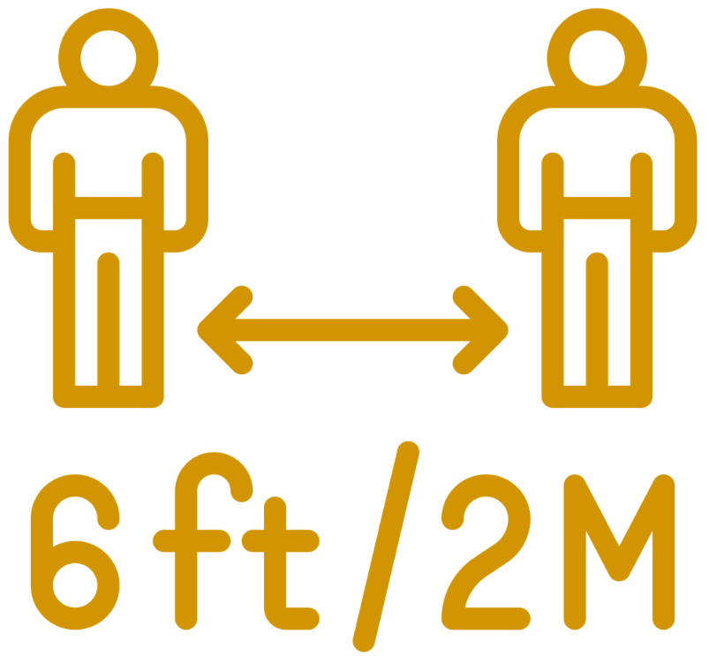

#NICE2METRE2METRENICE!
What will my child experience during their time at school?
We are delighted to be able to welcome all our children back to school! There will be slight differences in their day-to-day experiences, but our school values still apply in all that we do each day. Your child will surprise you with how easily they adapt to any changes outline in this booklet.
Step-Up September
During September, children will experience a range of activities which focus on rebuilding relationship with their classmates and teachers; reinforcing readiness to learn; and mental health and wellbeing. Our school rules and values will also be reinforced.
Children will revisit key learning from this year in Maths and English. There will be a focus on counting, the 4 operations and place value in Maths. English will focus on punctuation, spelling and grammar rules, reading and phonics.
All children are returning to their previous class teacher. The current Years 3-5 will keep this teacher all year as they move to Years 4-6. Early Years, Year 1 and Year 2 will move to their new classroom and new teacher on Monday 5th October. During Step-Up September, children will spend time with their new class teachers.
On their return to school:
- Children will be given a seat in class and, in Year 2 upwards, be seated in rows as per guidance issued by the Department of Education.
- In all year groups, the normal curriculum offer will remain. No subjects will be removed.
- In the Early Years’ classes, children will continue to learn through play and use a range of resources, both in and out of the classroom.
- Resourcing will be well thought out, washable and limited. Resources will not mix bubbles without being deep cleaned.
- Children’s social distancing will be promoted but children will play in a wider, phase bubble at playtime and lunchtimes. Pre-cleaned and bubble specific play equipment will be used, and social distancing games promoted by staff.
Additional Measures:
- Classrooms, toilets and surrounding areas will be cleaned regularly.
- Your child will be asked to wash their hands as a minimum:
    - Upon arrival
    - Before and after playtimes (including lunchtime play)
    - Before and after eating
    - Before home time.
- Special, lidded tissue bins will be provided for children to ‘Catch it, bin it, kill it.’ These will be emptied regularly throughout the day.
School Lunches
- In order to ensure we can maintain the integrity of class bubbles and for practical reasons regarding cleaning and staffing, lunches will be delivered to classrooms in individual bags.
- As a result, lunches will be sandwiches with a choice or cheese, ham or egg.
- All children from Reception to Year 2 remain entitled to Universal Infant Free School Meals.
- Children in Years 3 -6 who are not entitled to Free School Meals will be able to order as usual. Payment is via ParentPay only.
- Lunches, included for children entitled to Free School Meals, must be ordered in advance. WE will not be able to provide lunches for children who have not pre-ordered. More information on how to do this will be sent out in late August.
When guidance changes to make it safe to return to eating in the school hall, we look forward to returning to our full menu.

Collecting your Child:
- To ensure collection is organised and safe for all children, parents will be allowed in site.
- Please arrive promptly and continue to maintain social distancing.
- Your child will be sent to you. Please leave the site immediately with them and continue to maintain social distancing.

How can I speak with my child’s teacher or a member of staff?
- Parents are not permitted to enter the classrooms, but we still wish to offer you our utmost support.
- Class email addresses will be active from September to enable you to contact your child’s teacher. Staff will not be able to respond to emails during the school day when teaching. Emails will only be responded to between 8am-8.30am and 3.30pm-5pm, Monday to Friday.
- The school office should be the main point of contact during the school day.
  - Telephone: 01494 783070. Staffed between 8am and 3.45pm
  - Email: office@ivingswoodacademy.org
- If you feel it necessary to visit the office, you will be asked to apply hand sanitiser. Only one person may enter the office at a time.

We are grateful to all our families for their support at this time.

