Tuesday 24th March 2020
Good Morning Everyone!
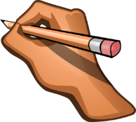
Today we are going to practise our handwriting and write 5 of our key words. We are also going to remind ourselves about 3D shapes.
Please carefully write over the top of the letters on your handwriting sheet on the first page in your home learning journal.
Then using as many different colours as you like, write the words dad ,him, big, her, look, 3 times in your home learning journal.
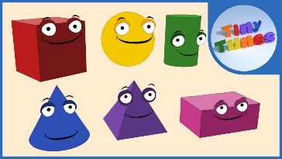
Now let’s have a look at this 3D shape song together
https://www.youtube.com/watch?v=guNdJ5MtX1A

Do you need to burn off some energy? Then Go Noodle!
Follow the link bellow and show your family how to Go Noodle!
https://family.gonoodle.com/
See you tomorrow
Mrs Allen, Mrs Beaulah and Mrs Parry



