Thursday 30th April
Morning,
How did all the dancing go yesterday? I liked speaking to some of you yesterday and hearing all about your moves. I am also thrilled to hear about how well you are doing with your English and maths work. I know some of you find it trickier to do, but I am pleased with the effort you are putting in – keep it up.
English
Today we are learning about the use of apostrophes in contractions. Contractions are shortened words. For example: do not – don’t. The apostrophe (‘) goes where the letter taken away should be. We have learnt about this before in class, so you all should be mini experts. Before you watch the clip see how many words you can write which use an apostrophe.
There are four suggested activities if you follow the link below. You don’t need to do all of them – pick the ones you like.
https://www.bbc.co.uk/bitesize/articles/z4p2mfr

Maths
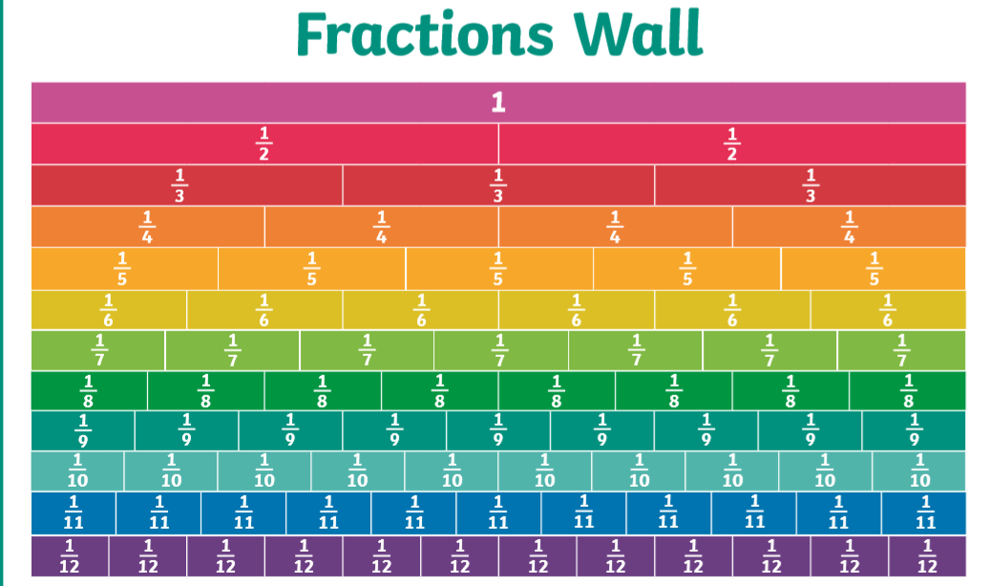
Today we are learning about equivalent fractions and this fraction wall may help to show those that are equivalent. Equivalent means the same or equal.

Parents, the worksheet asks the children to shade fractions that are the same. Without printing the sheet out, you can discuss with you child how many they would shade. Please practise saying the sentences together such as one half (½) is the same as two quarters (2/4).
The lesson we need is week 2, lesson 5. Equivalent Fractions (1)
https://whiterosemaths.com/homelearning/year-3/

Other activities
- Make some sock puppets and put on a show
- If you have an old show box at home, turn it into a shoebox house for your Lego characters or other small toys.
Well done and speak soon,

Mrs C Flynn

