Friday 1st May
Pinch, punch first of the month. No returns. We’ve come to the end of another week apart and I am really enjoying hearing from you when I call and seeing the work and pictures that you email to the office. I do hope you are managing to keep happy and safe. I know it can be a little boring sometimes but keeping safe and happy is the most important thing to us all.
English
Today we are continuing our learning about the apostrophe. Yesterday it was being used to shorten words such as: it is – it’s and today we are using it to show possession.
For example: Sarah’s bed is all messy. The children decided that Tom’s painting was the best.
Follow the link below and complete the activities on how to use the apostrophe correctly.
https://www.bbc.co.uk/bitesize/articles/zmq9kmn
Maths
Today you have 4 challenges to solve. The first two are easier, but I know if you try really hard you could solve all four. Maybe you could give yourself a certificate if you get them all right and you can be our class champion. Let me know next week how many you got correct. The answers for the challenges are at the bottom of the webpage – so no cheating!! Click the link below and good luck.
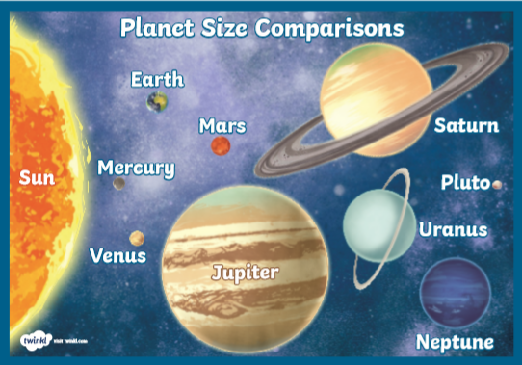
https://www.bbc.co.uk/bitesize/articles/zbqrcqt
Other activities
Space Day
On the first Friday of May, Space Day is celebrated in order to promote observation of the other, many planets around us. This is a picture showing the different planets in our solar system. Can you name them all in order? Maybe you could design your own planet. What colour and size would it be? Would there be life on the planet? What would the atmosphere be like? Would it have rings like Uranus and Saturn?

Have a good weekend and I’ll speak to you next week,
Mrs C Flynn

