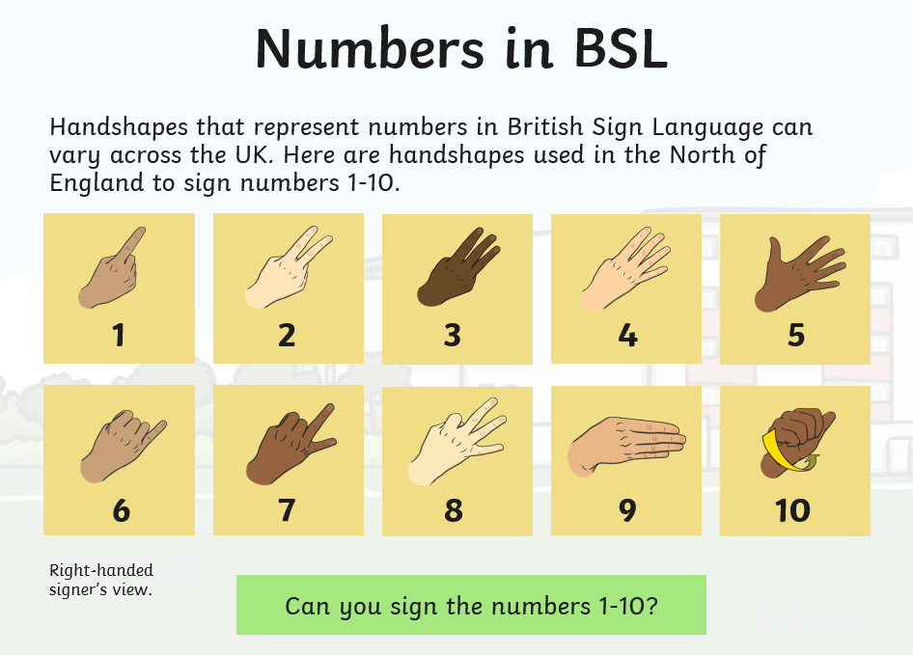
Wednesday 6th May
Deaf Awareness Week
This week is Deaf Awareness week. Being deaf means that you cannot hear. Some people are born deaf, some become deaf through illness and some become deaf with age. You can have difficulty with hearing or be completely unable to hear. Here are the British Sign Language numbers from 1-10. Your challenge is to learn them and then teach them to your family. Good luck.

English
Today we are learning about noun phrases and how to expand them. Last week we learnt about nouns and adjectives. We are combining them. Watch the link below and follow the activities.
https://www.bbc.co.uk/bitesize/articles/zhfgcqt

Maths
Well done for all you hard work with the fractions so far. Today we are going to order fractions. You need to know which is the largest and which one comes next.
Watch the link and answer the questions. On the worksheet are some questions where you are asked to shade, do not worry about those questions. You can discuss them together instead.
file:///F:/School%20closures/WB%204th%20May/Wed%206th%20Maths.pdf

Other activities
- Music lesson https://www.bbc.co.uk/bitesize/articles/z6mmxyc
- Build a den with your duvet and blankets, then read a book.

Well done and speak soon,
Mrs C Flynn

