Thursday 7th May
This is the end of the working week for us – well done on all your hard work. Because we have been doing so well, we can have an extra long weekend. Tomorrow is a special bank holiday because it is 75 years since the first Victory in Europe day, to mark the end of the second world war.
English
Today we are learning about recounts. On the webpage are the videos and suggested activities along side the success criteria for writing a recount.
https://www.bbc.co.uk/bitesize/articles/zkpvbdm
Maths
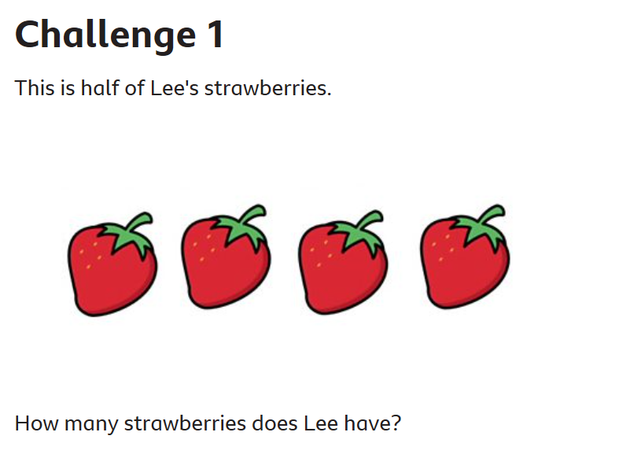
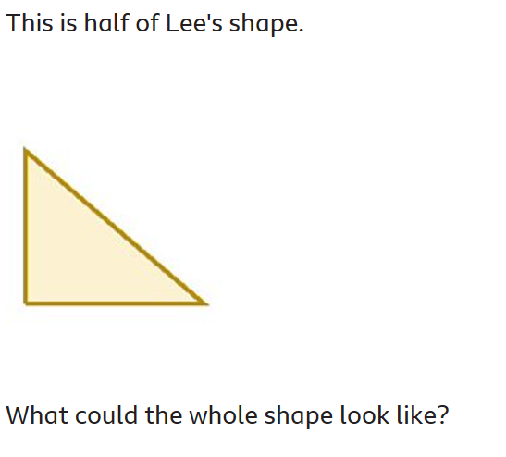
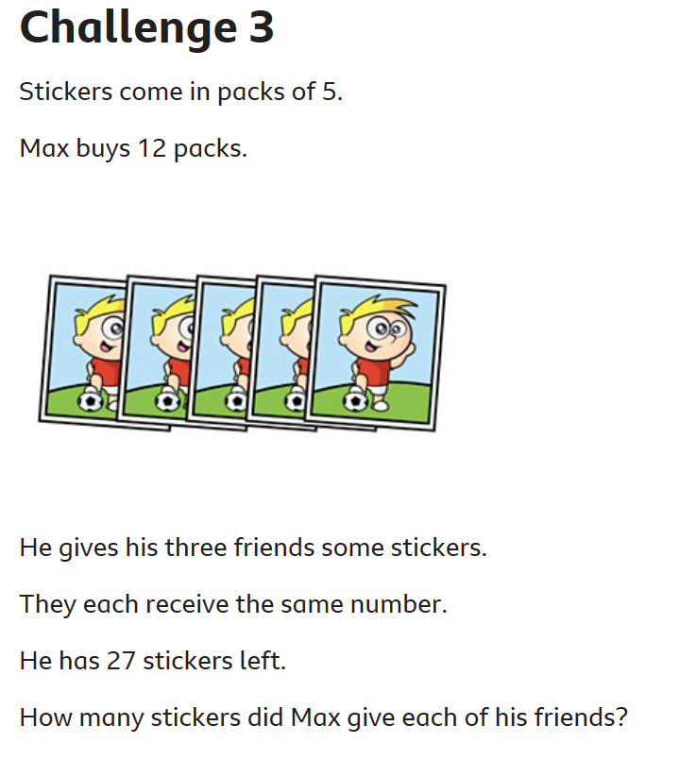
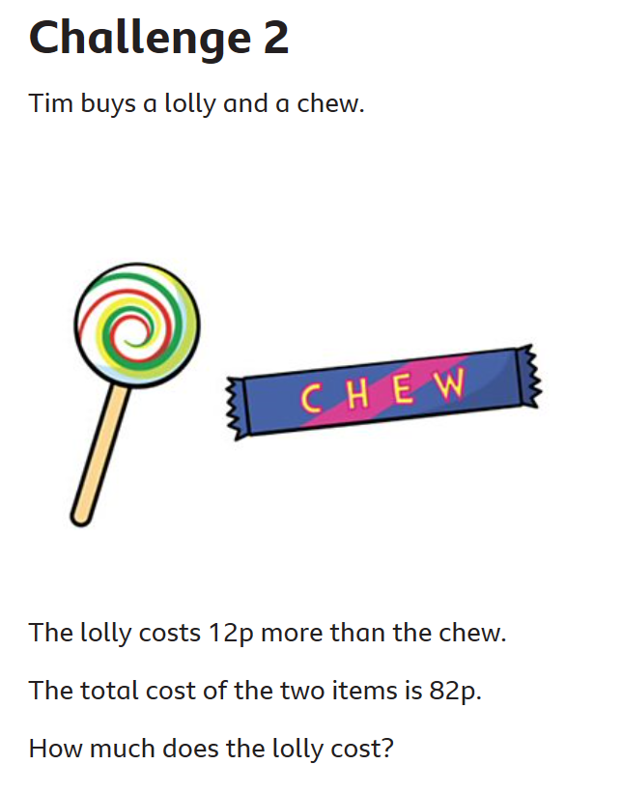

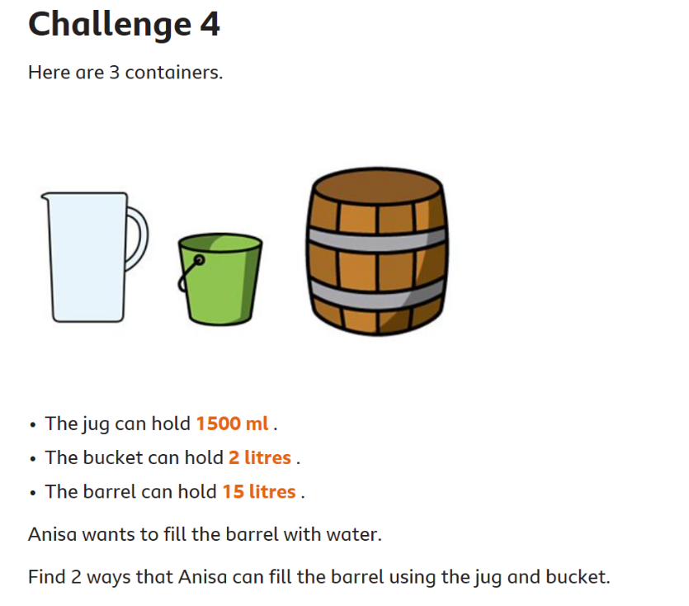
Answers for each challenge are at the end of these pages. Give yourself a house point for each correct answer.

Other activities

- Attached are some materials from Twinkl about VE day. As a class the children do love a wordsearch. It maybe a little trickier reading on the screen, but I am sure they can still do it. Set a timer for 5 minutes to add an extra challenge.
- The reading activity explains VE day.
- If you can print out the last picture and colour it in. If you are unable to, maybe you can draw your own picture of people celebrating the end of the war.
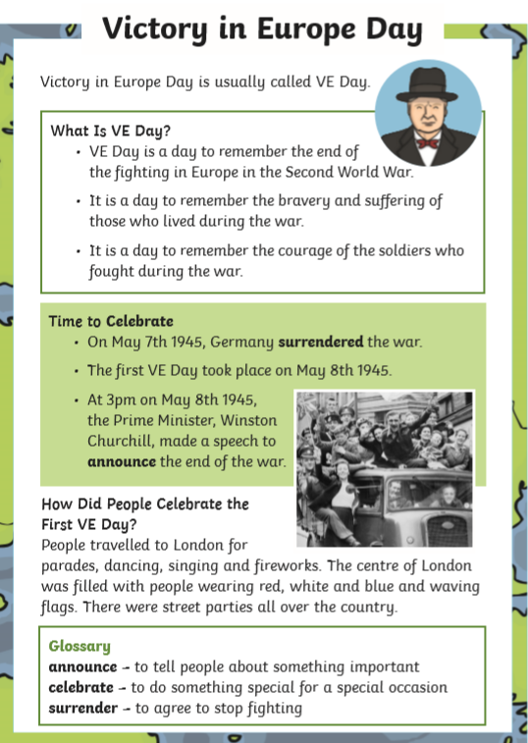

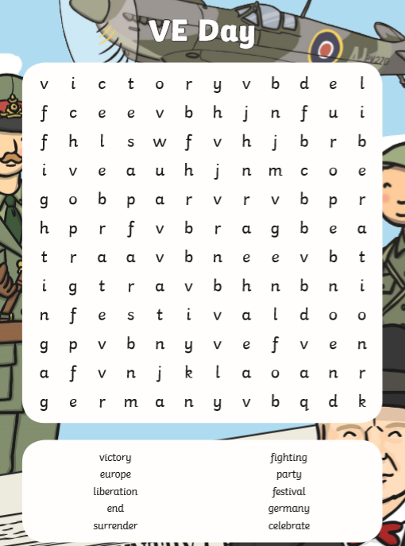

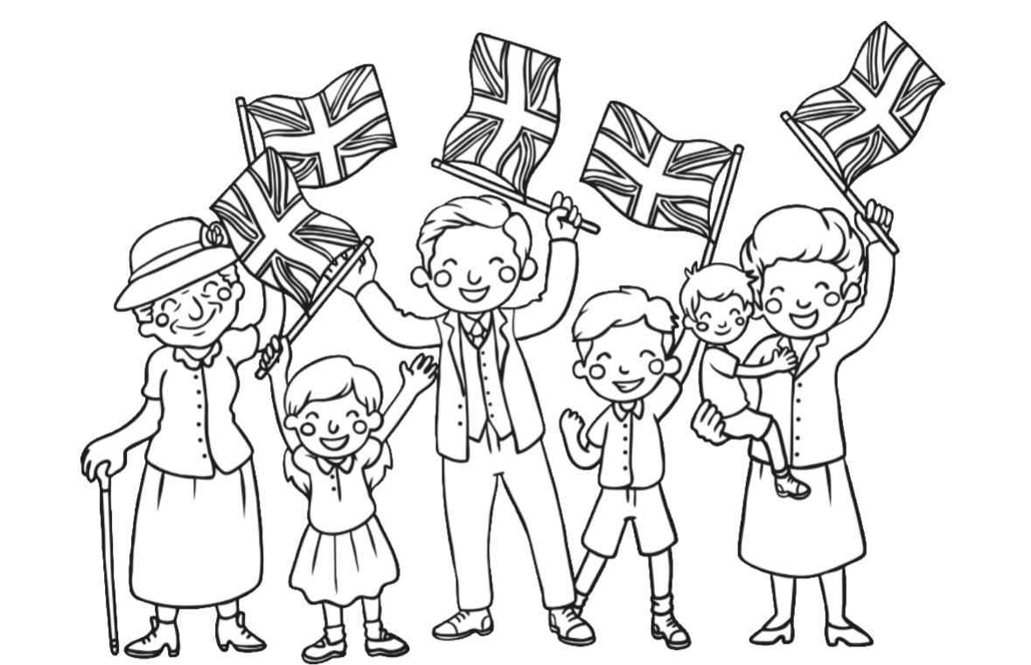

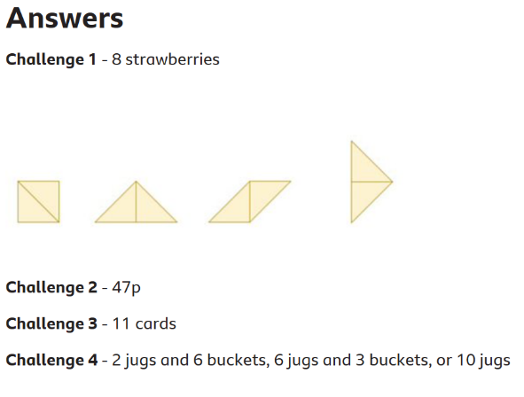
Happy Birthday Filip for tomorrow!
Well done and speak soon,
Mrs C Flynn

