Topic Work Year 3 and 4 - Wednesday 13th May Time Zones https://www.bbc.co.uk/bitesize/articles/z48fvk7
Watch this clip by following the link above  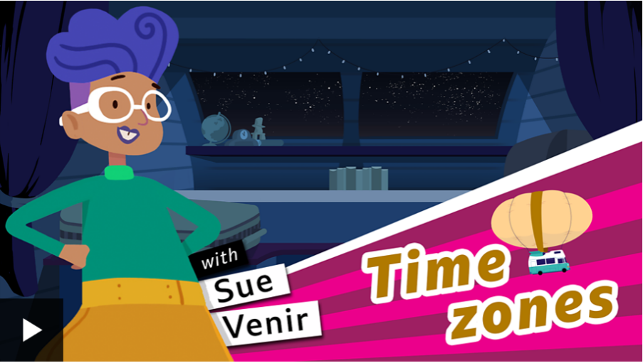 | Activity one  Play this game from the link above.  
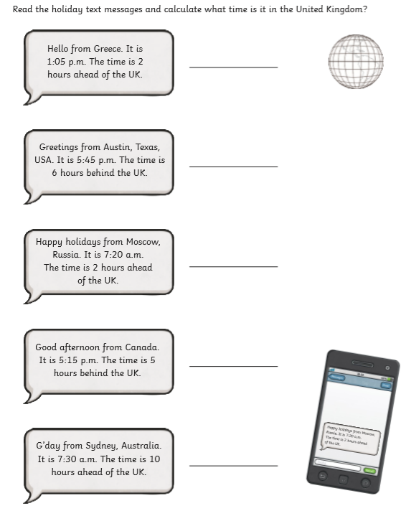  Activity 2 | Activity 3 Use the internet to find out the different times in various places around the world.  

