Wednesday 20th May
Happy Birthday, Ria!!
This Photo by Unknown Author is licensed under CC BY-SA
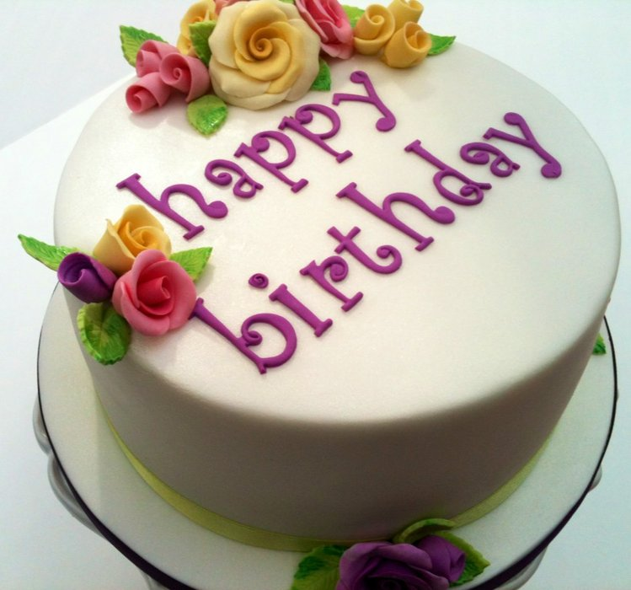

English
Today we are learning the difference between formal and informal language and when we need to use each type.
Follow the link below to find the clips and the suggested activities.
https://www.bbc.co.uk/bitesize/articles/zkkj2sg
Maths
Today we are learning formal multiplication methods. We are multiplying a two-digit number by a one-digit number. The link takes you to the White Rose site where you can watch the clip to learn how to do this method correctly.
https://whiterosemaths.com/homelearning/year-3/
Other activities
- You should have received the separate Topic and Science emails today – remember you have a week to complete these.
- Eat an ice-lolly (you can always make your own if you haven’t got any!)
- Sit in the shade and watch the birds
- Keep cool and drink plenty of water
Take care,
Mrs C Flynn

