Science Year 3 and 4 Vertebrates and Invertebrates Wednesday 20th May 2020
https://www.bbc.co.uk/bitesize/articles/zr4kd6f
Watch these three clips by following the link above  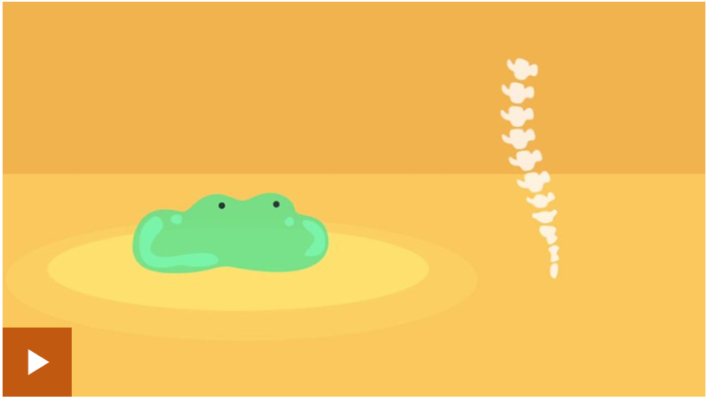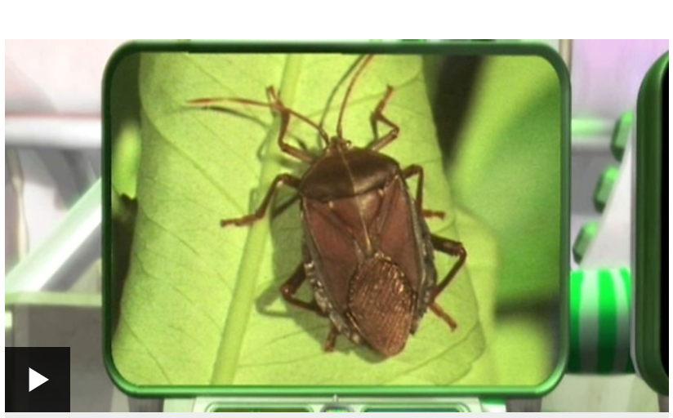  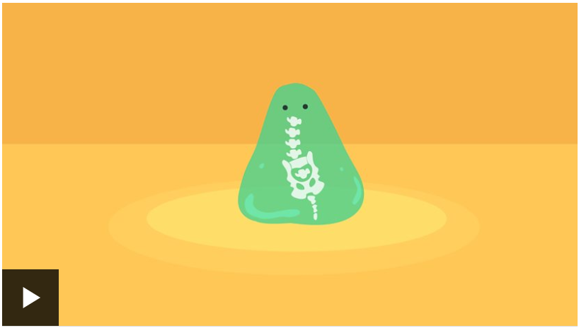 | Activity one  Sort the animals into vertebrates and invertebrates in this game, and then see how much you’ve remembered and learned by taking this quiz:  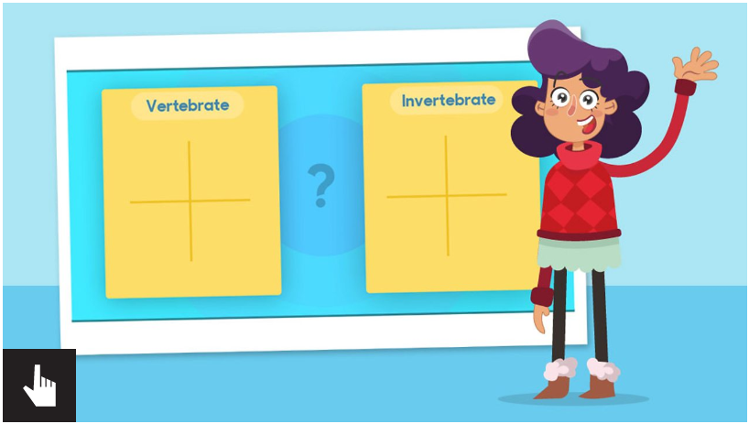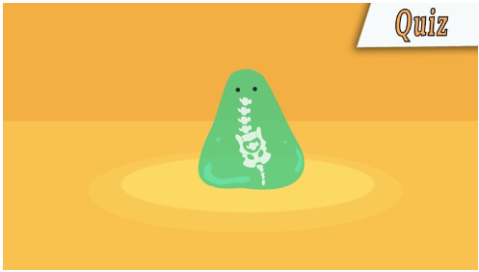
Activity 2  Go on a SPIDER SAFARI! Follow the instructions in the link and on the document to explore the insect world both inside and outside your house, using your new knowledge about vertebrates and invertebrates.   | Activity 3  If you’re really confident in your new knowledge, use this link to explore more fun quizzes and interactive activities:  https://app.senecalearning.com/classroom/course/387be3cf-f0c3-401f-9de4-e8658803ed6d/section/4384dc08-61c4-4fdb-ad85-26cac159972d/section-overview  

