Tuesday 2nd June
Morning everyone,
I do hope that you managed to have a good half-term. The weather was amazing! We had the paddling pool out in the garden and played in it nearly every day. As a family we went on some woodland walks and we had a picnic too.
All the teachers are in school this week busily preparing for those children who are allowed to return. I know that some of you will be disappointed that Year 3 are not coming back yet and some of you will be relieved! I look forward to seeing you all soon – I miss your little faces. For now, Year 3 , we will continue our learning this way and I will continue my phone calls home. Remember you can always contact me via the school office if you need anything, or if you miss my calls.
English
Our English lesson today comes from BBC bitesize and involves hearing a story called ‘You’re a bad man, Mr Gum’ being read by Joanna Lumley. I hope you enjoy it. Follow the link to find the page and suggested activities. https://www.bbc.co.uk/bitesize/articles/zkttpg8
Maths Challenge Time!
Challenge 1  Jane is standing in a queue.  There are 5 people in front of her.  There are 2 people behind her.  How many people are in the queue? | 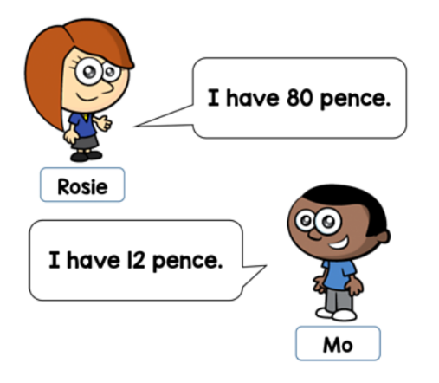  Challenge 2  Rosie gives Mo 25 pence.  How much more money does Rosie have than Mo now?
Challenge 3  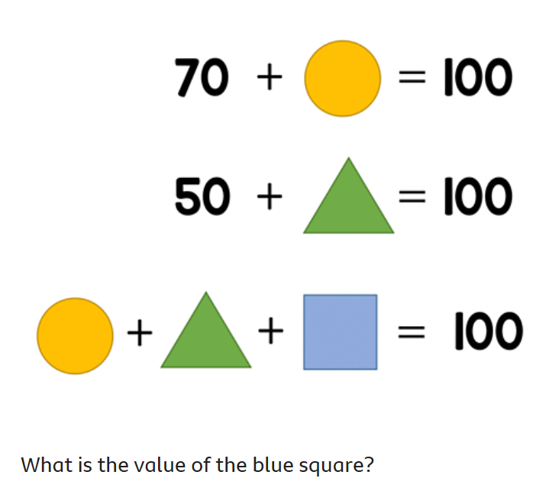 | Challenge 4    The perimeter of this regular hexagon is 42 cm.  Four of these hexagons are put together to make this shape.  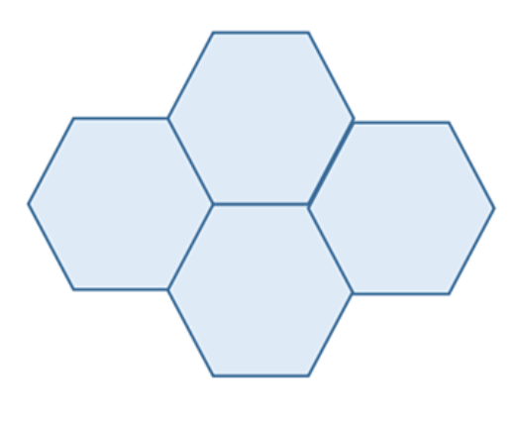  What is the perimeter of the shape?

Other activity ideas
- Play TTRS
- Practise counting in French and Spanish – use YouTube clips to help you remember them
- Practise tying your shoelaces if you cannot do them yet

Well done and speak soon
Mrs C Flynn

