Monday 8th June
English
Today we are using our reading skills of inference. This is a very important reading skill and one we all need to practise. Follow the link to find the clips. This lesson involves watching clips to understand inference and when we are together again, we can use these skills when we read our class books. https://www.bbc.co.uk/bitesize/articles/zfn6pg8
Maths Challenge Time
Challenge 1  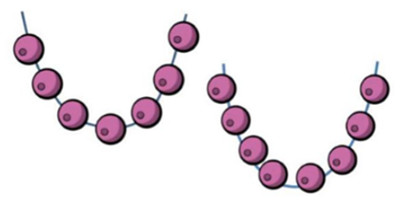  Sal has 20 beads. She uses some beads to make these two necklaces.  How many beads does she have left? | Challenge 2  George is thinking of a 2-digit number.  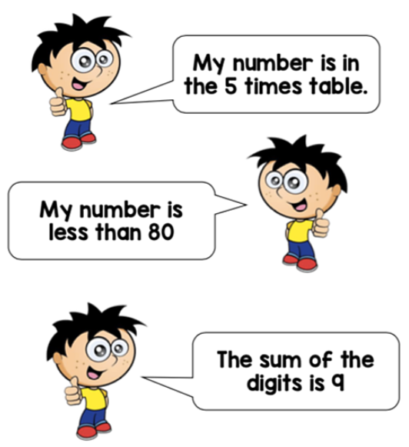  What is the number George is thinking?
Challenge 3  Two numbers, A and B, are marked on the number lines.  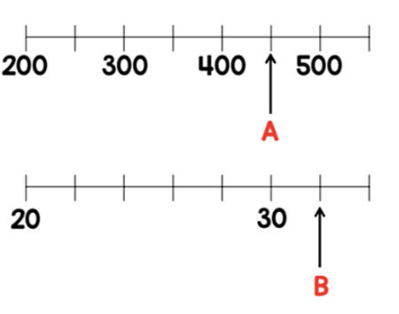  What is the sum of A and B? | Challenge 4  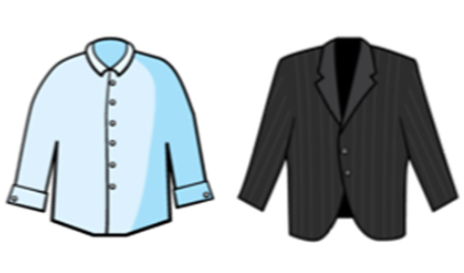  Max buys a shirt and a jacket.  The jacket costs £25 more than the shirt.  The total cost of the shirt and jacket is £87. How much does each item cost?
Well done and speak soon,
Mrs C Flynn

