Wednesday 10th June
As today is Wednesday, you should receive the Geography and Science learning alongside this English and maths. Today we are learning about the environment in Geography and Monday was World Ocean Day. I like being by the seaside, walking in the sand and feeling the cold sea with my toes. I am looking forward to hopefully visiting a beach in the UK during the summer break. If you enjoy learning about oceans you can maybe watch a Blue Planet episode as they are available on BBC iPlayer.
English
Last week, we learnt what a fronted adverbial was and how to spot them. We are continuing this learning today and practising writing them.
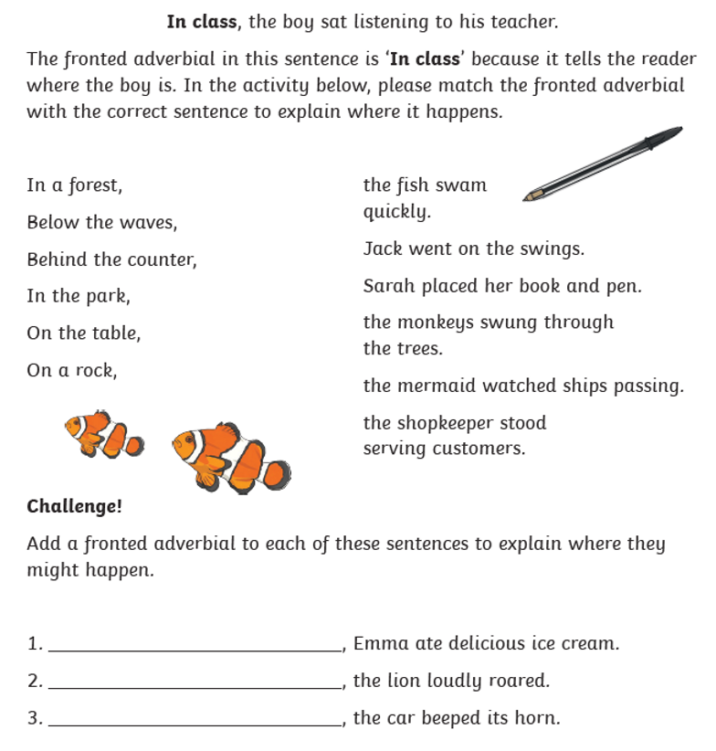

Maths
We are continuing our maths learning using the White Rose videos and work guides. This week we are learning from Summer Term – Week 6 – (WC 1st June) and our lesson today is Lesson 2 ‘Fractions on a number line.’ Click the link below to find the learning clip and the work has been sent separately.
https://whiterosemaths.com/homelearning/year-3/

Well done and speak soon,

Mrs C Flynn

