Friday 19th June
We’ve reached another Friday! I hope you are all doing well. Remember this Sunday is Father’s Day. So, if you are spending time with your dad or a special male in your life this weekend – I hope you have fun. This year I will not be able to see or hug my dad as he is not in my household. I am going to have to keep all my hugs for when I can see him.
English
The focus for the lesson today is nonsense poems. Nonsense poems are fun because they can be silly and full of nonsense! On the BBC Bitesize page is a poem by Spike Milligan called ‘On the Ning Nang Nong’. It is a nonsense poem and a bit of a tongue twister too. See if you can a family member can read it aloud. Can you read it without any mistakes? When you read this poem, can you hear any onomatopoeia words we learnt yesterday? Follow the link to see the clips and suggested activities.
https://www.bbc.co.uk/bitesize/articles/zv3v6g8
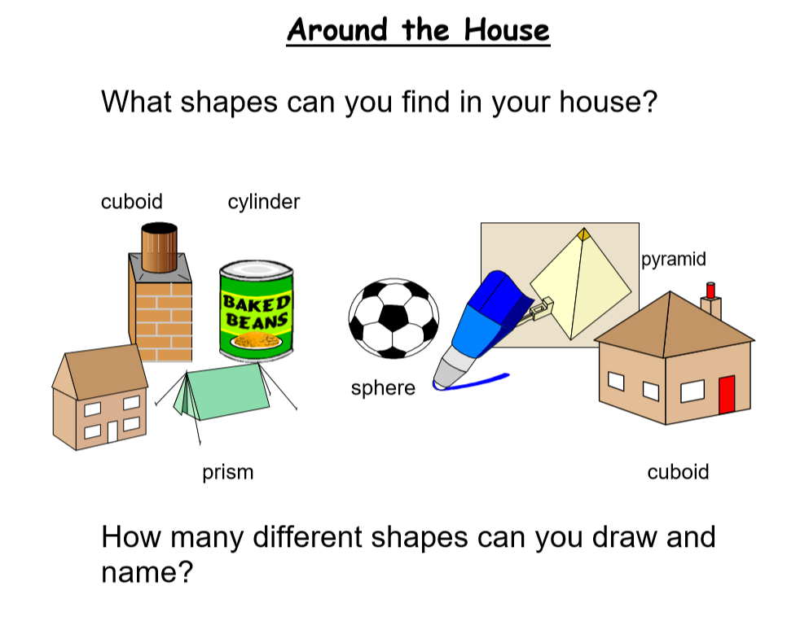
Maths

Other activities
- Draw a picture of what you can see from a window in your house
- Play TTRS
- Practise your handwriting and letter formation
- Watch a movie – well it is rainy outside!
Well done everyone,
Mrs C Flynn

