Monday 22nd June
Morning everyone, I do hope you had a good weekend and that you managed to enjoy some of the sunshine. Yesterday was the longest day and it was light until very late. I look forward to hearing what you have been doing in my calls this week. Remember you can always contact the school office for any support needed.
This week is National Sports Week. The organisers know that schools cannot do the fun activities now, so they have made some suitable for doing at home. Here is the link to the website where you can register for the activities to try. I am going to do this with my children at home too – I will let you know how we get on. https://www.youthsporttrust.org/national-school-sport-week-home
English
Today we are learning about alliteration. Remember what that is? Alliteration is when we select words that have the same sound to add detail to our sentence. For example: The wild white sharks whistled in the wind – the alliteration comes from the letter w.
Follow the link for the learning clip, quiz, and some examples of tongue twisters for you to try. Have fun!
https://www.bbc.co.uk/bitesize/articles/zc3v6g8
Maths - Sequences
Find the next number or shape in the sequence.





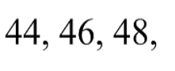

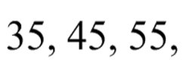

Now find the missing numbers that should be in the boxes
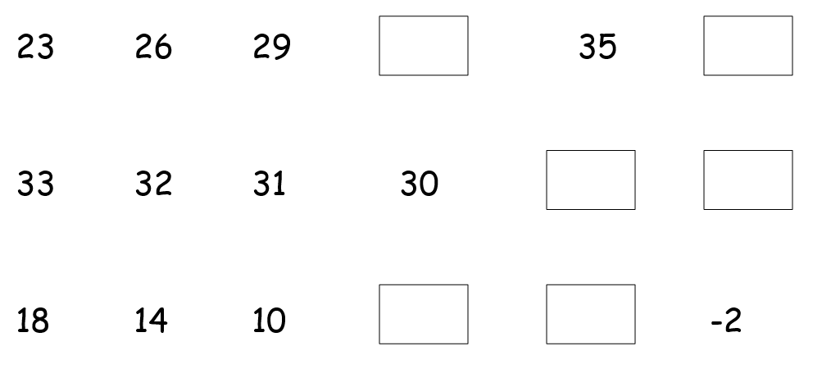

Other activities
- Make up your own pattern out of things in your house. Can you get someone to guess the next shape or colour in the pattern?
- Count to 10 in both French and Spanish (not at the same time!).
- Help with some house chores – maybe you could make the beds or fold some washing.
Well done everyone,
Mrs C Flynn

