Tuesday 23rd June
English
Our BBC Bitesize lesson is based around ‘Slime’ by David Walliams. You know I love reading books by David Walliams and I shared one with you on World Book Day. I have not read ‘Slime’ though. Have you? Some of the David Walliams books have been made into films and are available on BBC iPlayer – I recently watched Midnight Gang.
Follow the link to watch the clips of ‘Slime’ and to find the activities. https://www.bbc.co.uk/bitesize/articles/zrd4f82

Maths - Challenge Time
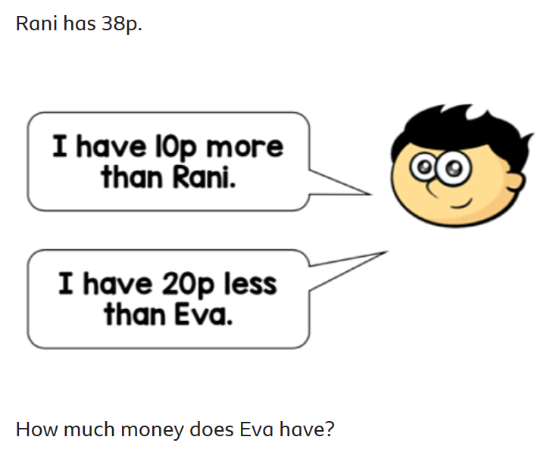  Challenge 1 | Challenge 2  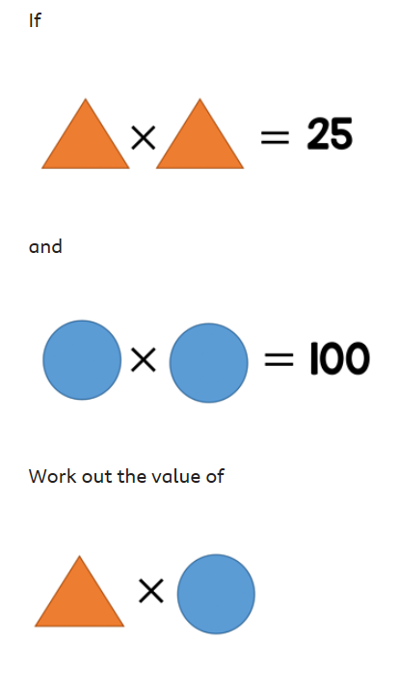
Challenge 3
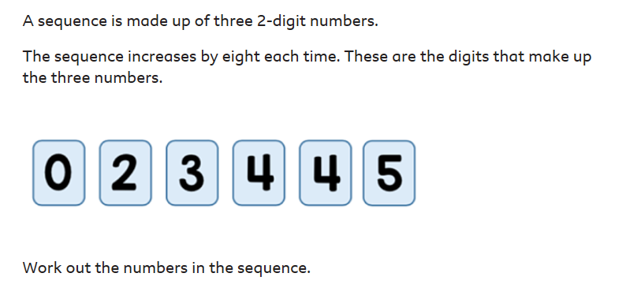
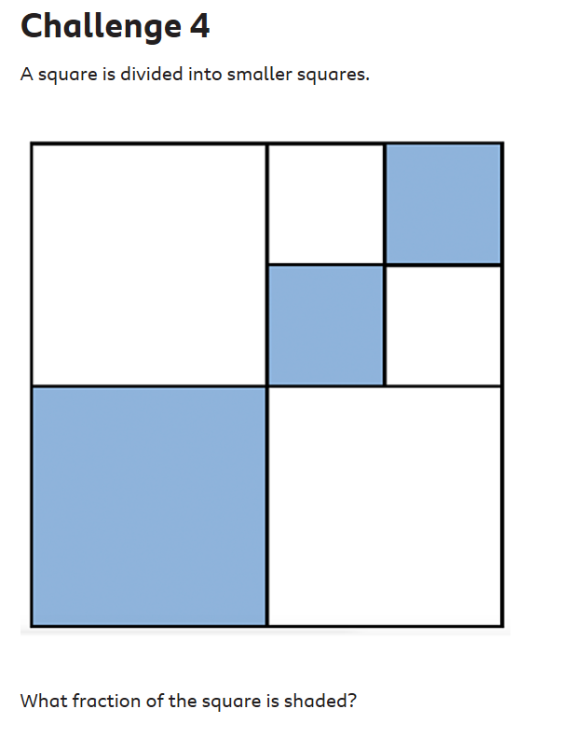
Other activities
- Stay cool and hydrated
- Play with water to keep cool
- Have an ice-lolly
Well done everyone,
Mrs C Flynn

