Topic Work Year 3 and 4 - Wednesday 24th June - Volcanoes https://www.bbc.co.uk/bitesize/articles/zhjqcmn
Watch the two clips by following the link above  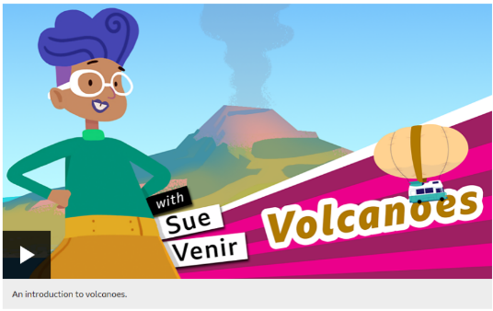  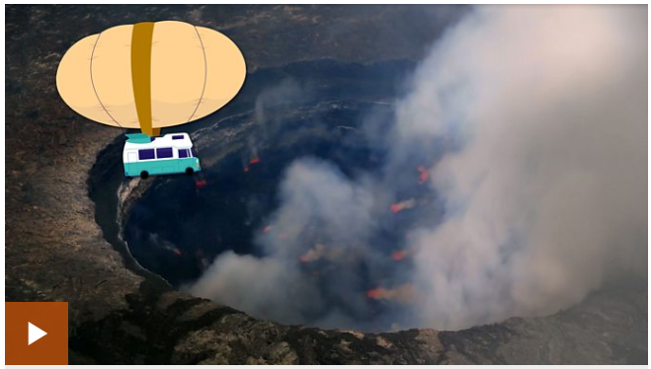 | Activity One Quiz time  Find the quiz on the BBC Bitesize page.  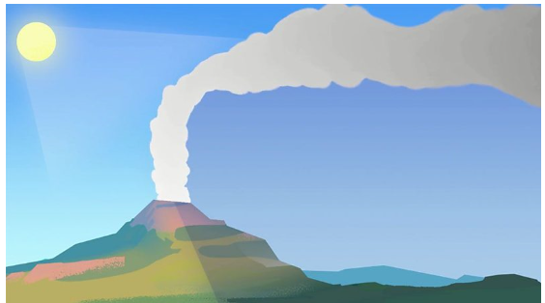
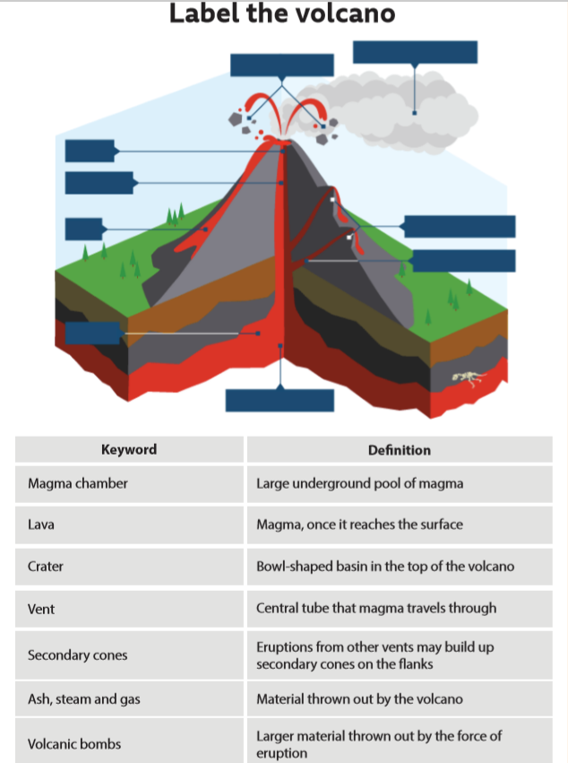  Activity Two | Activity Three  https://www.tigtagworld.co.uk/mindmap/#/lessons/CLASS00321  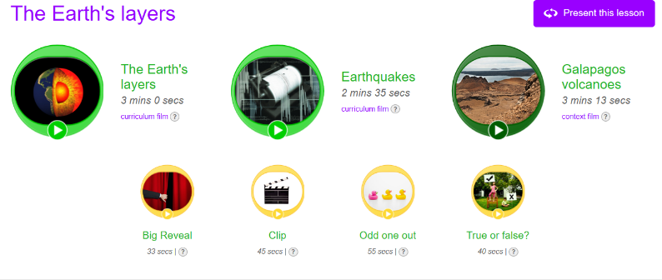  Follow the link for more learning clips to watch plus some games to play too.

