Science Year 3 and 4 Sound Wednesday 1st July 2020
https://www.bbc.co.uk/bitesize/articles/zb4jcmn
Watch the 3 clips by following the link above  I know that if you are in Year 4 you will again be really familiar with all this, do you remember watching the second video and recreating that experiment in class? See how much you can remember!  1 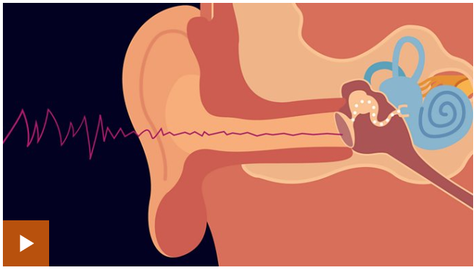 2 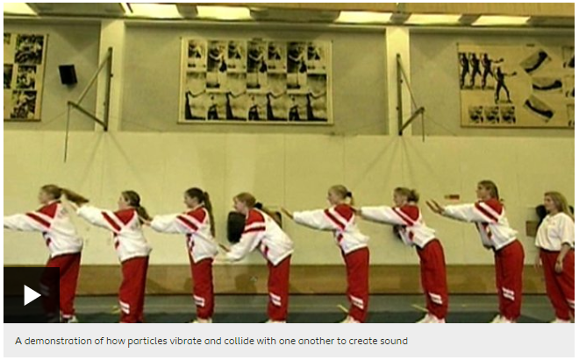 3 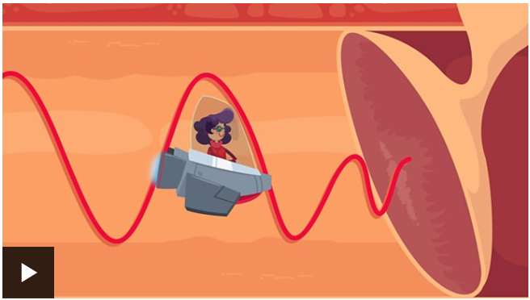 | Activity one  Have a go at the ‘fill in the gaps’ activity – can you find the correct term (word)?  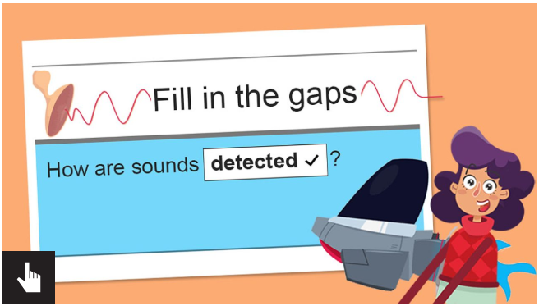
Activity Two  Test out your knowledge by taking the online quiz:  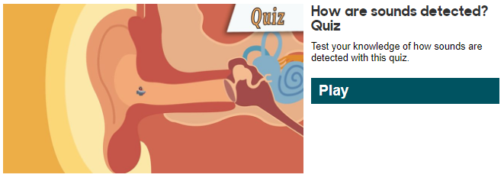 | Activity Three  Using the information in this lesson, create a poster to explain how we hear sounds. Use key vocabulary and diagrams to make your poster clear and eye-catching. If you wanted to take a photo of your finished poster and email it to us Mrs Flynn and I would love to see it!  Alternatively, if you wanted to do something more practical, here is a great website that has 7 awesome sound experiments that you can do at home! Its totally up to you, you could do as many or as few as you wanted. They look like loads of fun though!  - Make a paper cup and string phone  - Make music with a straw pan flute  - Listen to sounds travel underwater  - See the sound  - Make a stick harmonica  - Experimenting with sound waves  - Xylophone water jars  https://www.kidsacademy.mobi/storytime/sound-science-experiments/

