Thursday 2nd July
Well done to everyone who is trying their best to complete their work. I have been impressed by the photos that your parents send me.
English – Extract from Fantastic Mr Fox
Chapter One – The Three Farmers
Down in the valley there were three farms. The owners of these farms had done well. They were rich men. They were also nasty men. All three of them were about as nasty and mean as any men you could meet. Their names were Farmer Boggis, Farmer Bunce and Farmer Bean. Boggis was a chicken farmer. He kept thousands of chickens. He was enormously fat. This was because he ate three boiled chickens smothered with dumplings every day for breakfast, lunch and supper. Bunce was a duck-and-goose farmer. He kept thousands of ducks and geese. He was a kind of pot-bellied dwarf. He was so short his chin would have been underwater in the shallow end of any swimming pool in the world. His food was doughnuts and goose-livers. He mashed the livers into a disgusting paste and then stuffed the paste into the doughnuts. This diet gave him a tummy-ache and a beastly temper. Bean was a turkey-and-apple farmer. He kept thousands of turkeys in an orchard full of apple trees. He never ate any food at all. Instead, he drank gallons of strong cider which he made from the apples in his orchard. He was as thin as a pencil and the cleverest of them all.
Read the extract and discuss with your grown-up what you know about each one of the characters. This is characterisation. Are all the farmers the same? Why do you think the author made these choices?
Maths - Challenge Time
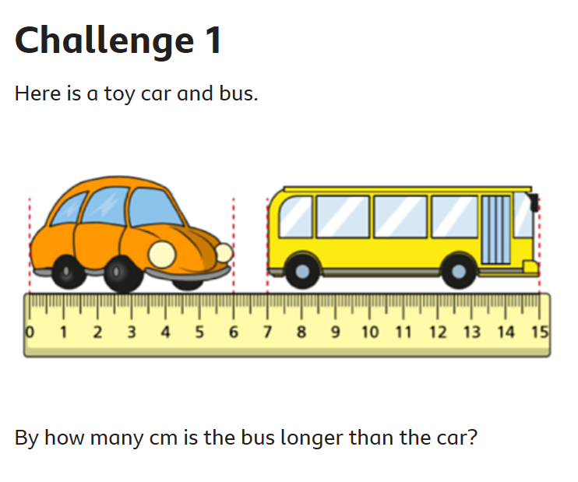 | 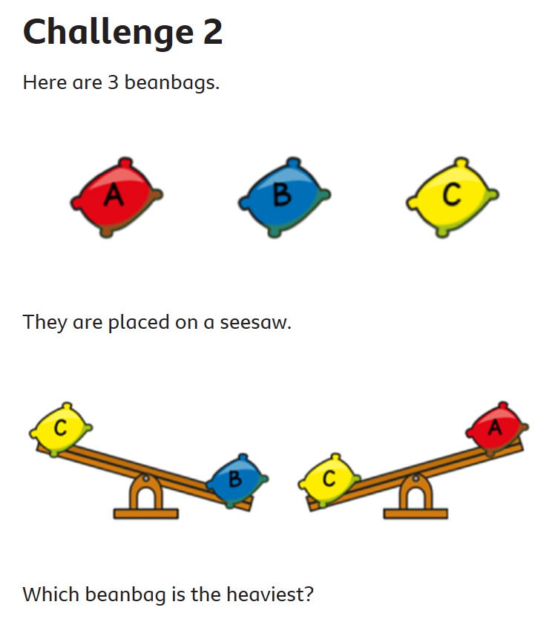
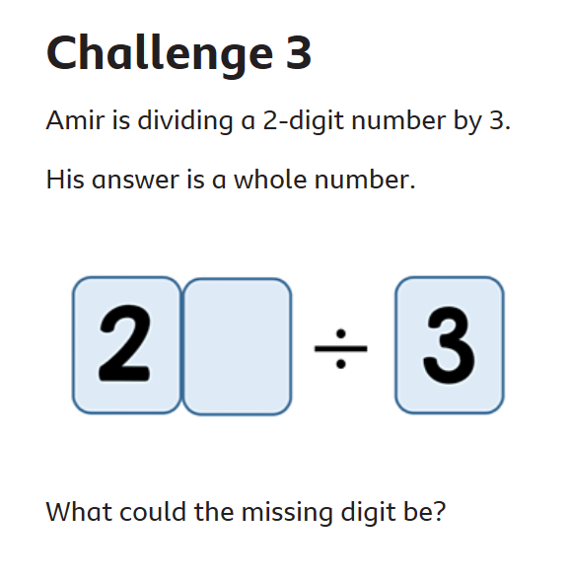 | 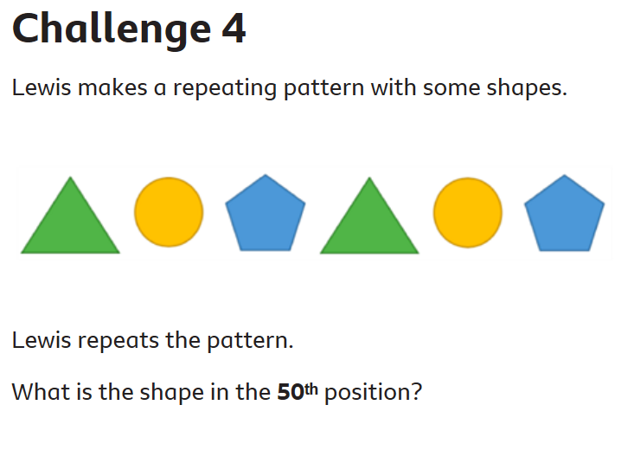

Maths continued…..
Play this Bobbie Bear game. Do you remember the work we did on different combinations? We put t-shirts and shorts together to see how many different combinations we could make. We ever did it with ice-cream flavours. In this game you start with two tops and two bottoms to dress the teddy bear. Once you work out all the different combinations, you get more items of clothing. Good luck.
https://www.nctm.org/Classroom-Resources/Illuminations/Interactives/Bobbie-Bear/

Well done.
Mrs C Flynn

