Monday 13th July
This is our last week as Year 3. Can you believe it? I know this has been the strangest year ever and that soon it is the summer holidays.
I am so excited to be back with you all in September, I am already planning what we are going to be learning.
On Friday I said I had some news to share….well … we have two new additions to the Flynn Family now. Please meet Tulip and Rose.

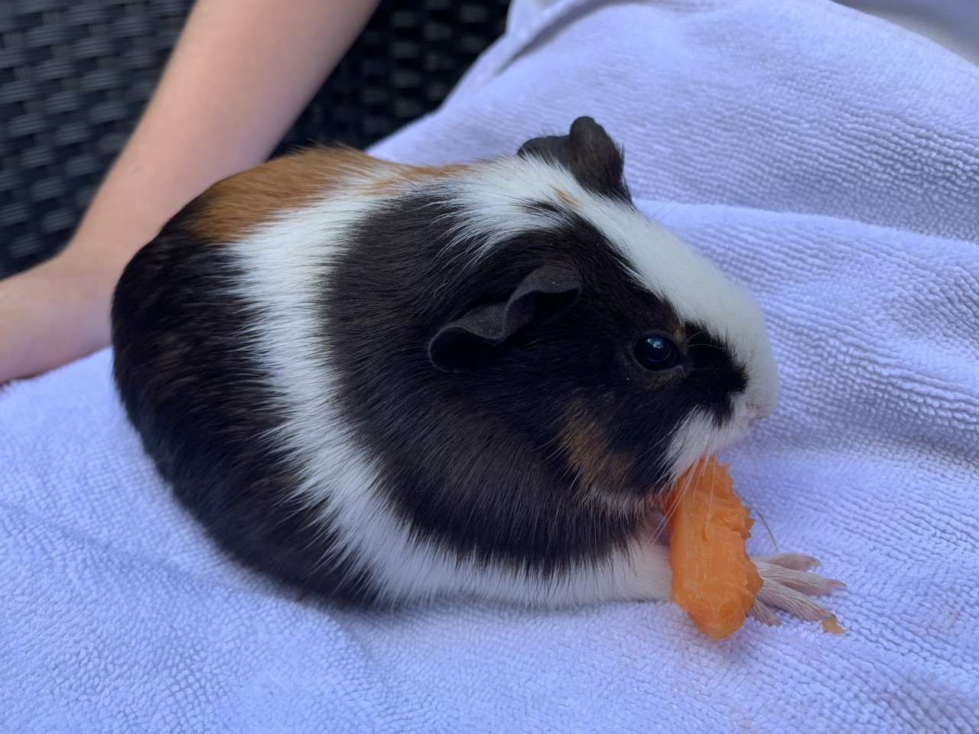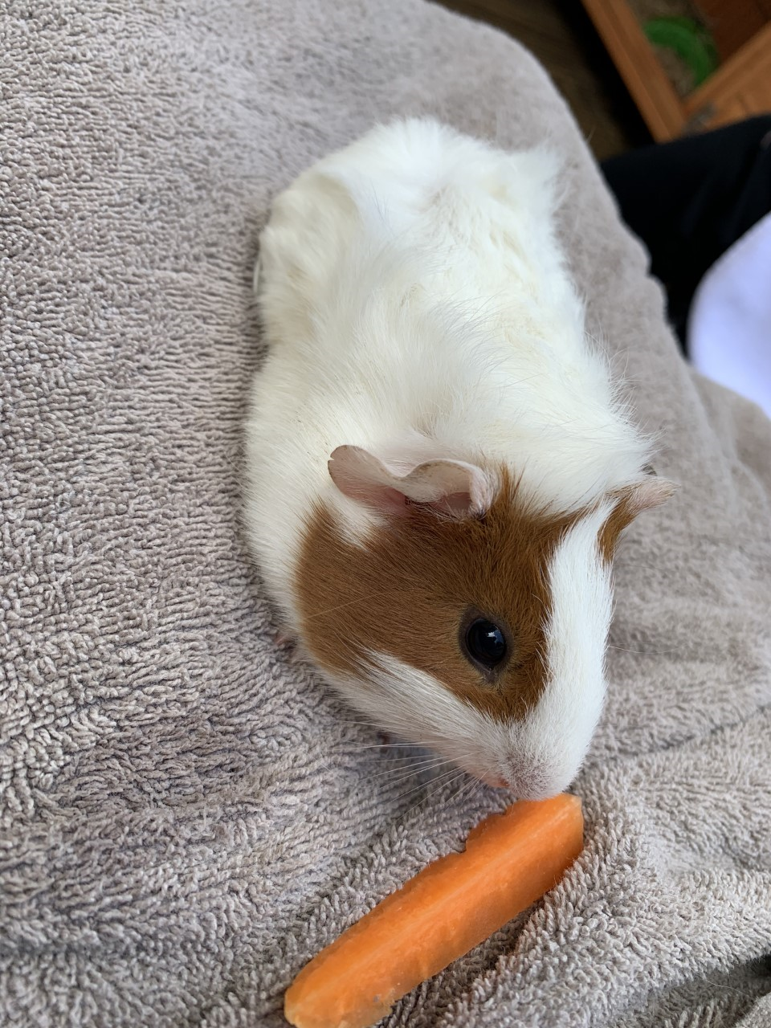
English
You have learnt about subordinating conjunctions in a previous lesson.
Today you’re going to revise what they are and use them independently in your writing. https://www.bbc.co.uk/bitesize/articles/zxqgn9q
Maths
Measuring Mass is the title of our work today. When do you ever measure mass? When you need to weigh yourself, when you weigh ingredients to bake and when you want to know how heavy your suitcase is. Can you think of anymore? Follow this link to find the learning video and the suggested activities at the bottom of the BBC Bitesize page.
https://www.bbc.co.uk/bitesize/articles/zndy6g8

Well done everyone,
Mrs C Flynn

