Wednesday 15th July
English
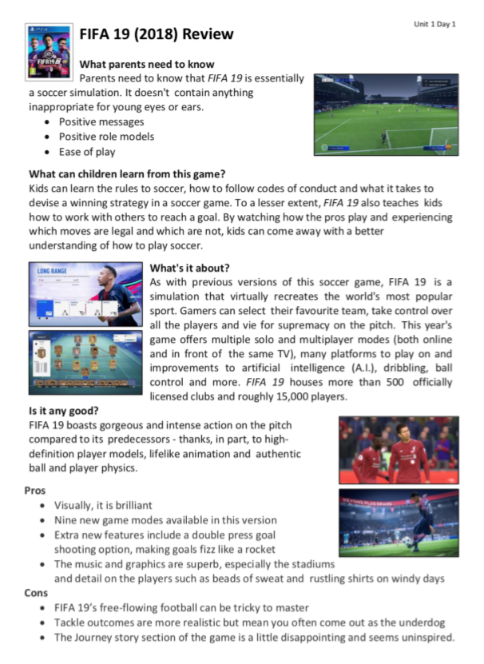
Here is an example of a review of a game called FIFA 19. I am pretty sure many of you have played it. Read through the review and decide with your grown-up what the features of a review are.

Your task is to go to https://www.bbc.co.uk/cbeebies/games and select one
of these games to write a review for. Remember to look back at the FIFA
one as a WAGOLL.
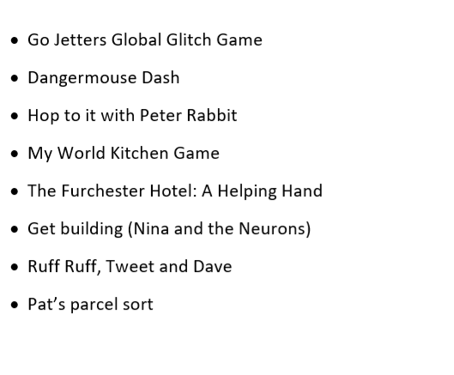

Maths
Today we are using our addition and subtract skills to add and subtract different masses. Follow the link to the learning clip and suggested activities. https://www.bbc.co.uk/bitesize/articles/z7mwr2p

Other activities:
- https://www.bbc.co.uk/bitesize/articles/zt32kty A drama lesson - how actors use their body language to portray their characters.
- Play TTRS
- Write out the alphabet in upper- and lower-case writing. Remember where they should stand on the line or go through the line.

