Tuesday 24th March 2020

Hi Year 4!

I hope you’ve all had a good long weekend with your families and are looking forward to getting stuck into some new activities! Remember, try your best to complete these tasks, working neatly and carefully in your blue book, however if you find something really tricky or struggle to understand it, don’t worry at all. I’ll be ringing everyone sometime this week and can answer any questions you might have. The most important thing is for you to challenge yourself, find lots of interesting things to keep yourself busy, and look after each other at home!

English
We are going to go over the rules of speech. Remember, we looked at these before in our English lessons, so this will help you to remember all the rules and practise using them properly. Use this video clip to help you remember:
https://www.bbc.co.uk/bitesize/clips/zvftsbk

Here are a few exercises, don’t worry about underlining anything, but can you identify the parts which are spoken out loud and which aren’t?

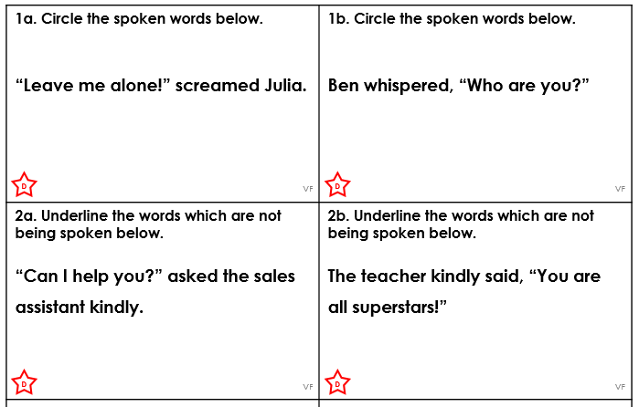

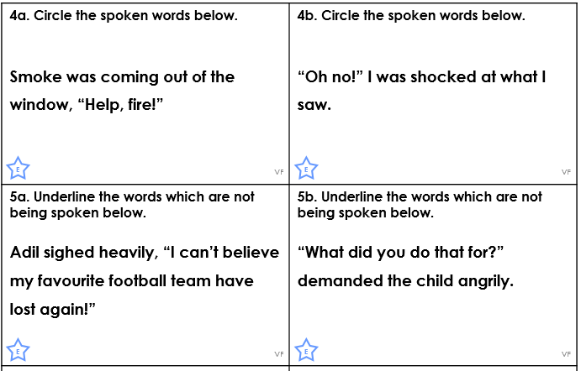

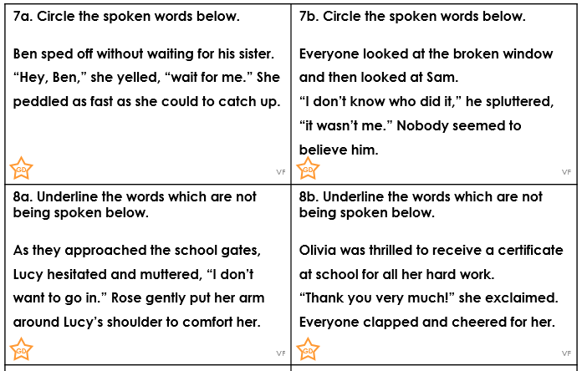

You don’t need to worry if you can’t do all of these – remember this is our Mild, Hot and Spicy challenge. Choose the level that is the right challenge for you!

Maths

We are going to recap the four operations over the next couple of weeks. Here I have some addition and subtractions for you to complete. Please remember to:

- Make sure that (for subtraction) the greater number is on the top
- Put your numbers into a column, making sure the place values line up
- Begin with the smallest place value
- If you are adding – remember to regoup any 10s into the next highest place value
- If you are subtracting: more on top no need to stop, more on the floor go next door and borrow some more, numbers the same zero’s the game!
- Check your calculation before you move on to the next
- © Can you use the INVERSE to check your calculations?

Addition
- 5,305 + 2,304
- 4,842 + 3,309
- 7,369 + 592
- 4,987 + 3,856
- 3,602 + 5,398

Subtraction
- 7,641 – 4,320
- 5,892 – 3, 468
- 9,632 – 4, 719
- 6,402 – 822
- 4,002 – 1,998

Remember to use your log in for TT Rockstars to keep practising and challenging yourself with your times tables. We also have lots of recommended websites with activities to keep your brains and bodies busy. These are all listed on the Ivingswood Academy website here:

https://www.ivingswoodacademy.org/page/?title=Useful+Websites&pid=103

