Year 4 25th March 2020

English
Continue recapping how to punctuate direct speech. Practise identifying the answers for the first two questions in the block, then write out the speech with the correct punctuation in your blue books for the third. If you can, choose two challenges that are right for you, either MILD and HOT, or HOT and SPICY.
MILD
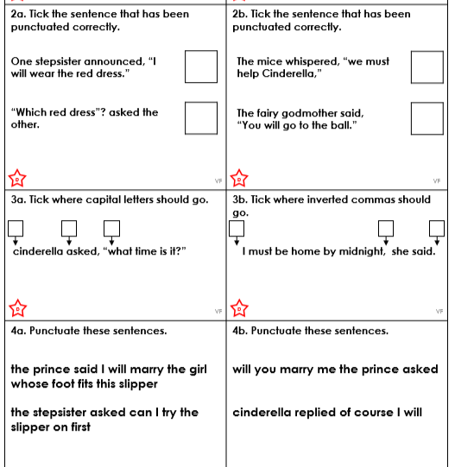

HOT
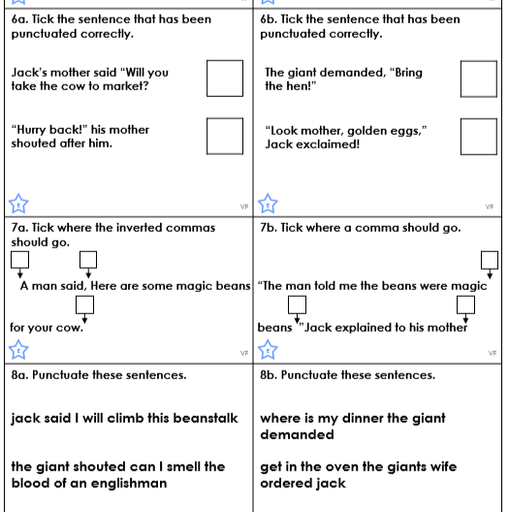

SPICY
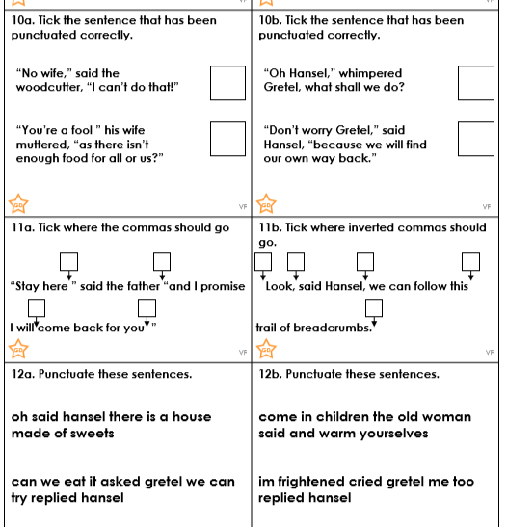

Maths
Here are some word problems involving addition and subtraction. See if you can work out which it is from the language used, and then follow our success criteria that I set yesterday to lay out and solve the calculations in your books. Good luck – and remember, don’t worry if you find it tricky, you can talk to me about how it’s going later this week.



