Year 4 25th March 2020

English
MILD
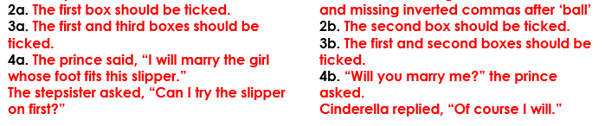
HOT
SPICY


Maths


