Year 4 Tuesday 28th April 2020
Hi everyone,
I hope you got on ok with Monday’s work – the answers should be going up for you to check against today. The BBC Bitesize website hasn’t put up Tuesday’s lesson yet, so I thought we could have some fun with an alliteration tongue twister competition. If you remember, alliteration is where you make your writing interesting by choosing to put some words close together that begin with the same letter or letter string. It’s a bit like rhyming, only you think about the start of the word and not the end of the word. Here are some examples:
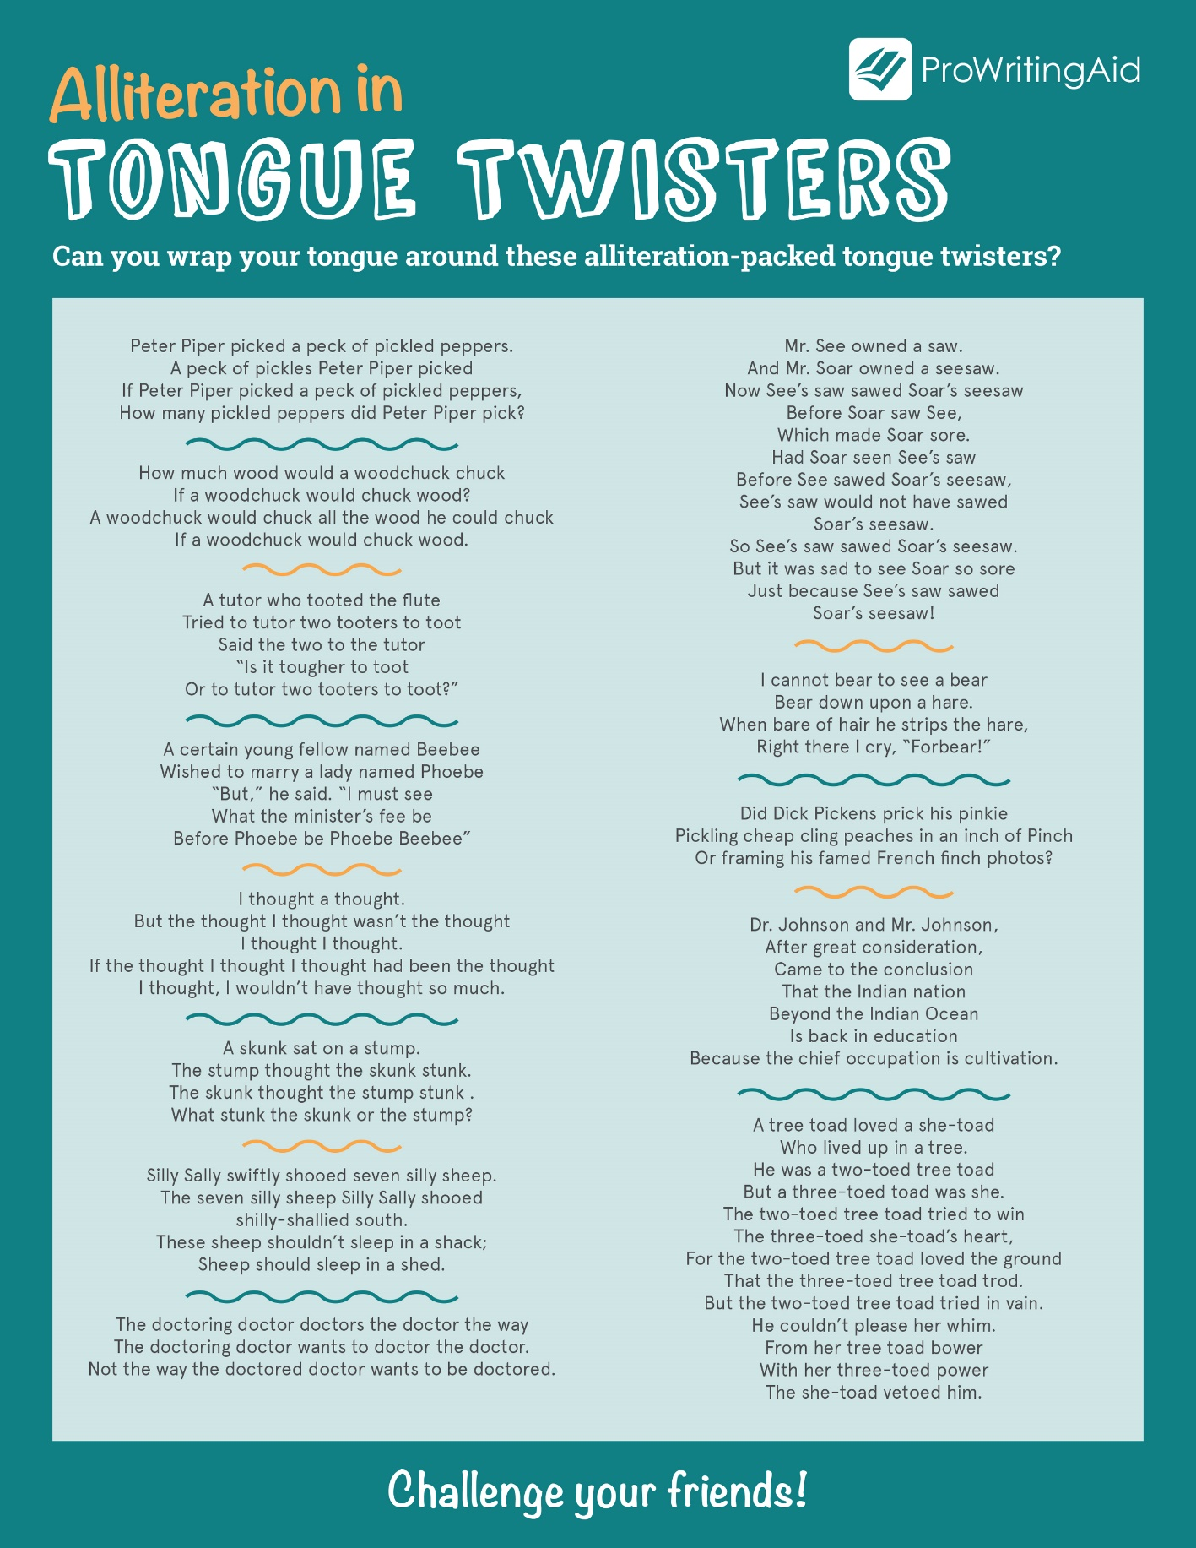
Here is a fun quiz to help you work on your alliteration skills:
https://www.educationquizzes.com/ks2/english/alliteration/
TASK
I would love you to write your own silly tongue twister, using as much alliteration as you can. Then practise saying it out loud yourself – how fast can you go? Challenge your family to beat you!
Here is a clip about alliteration and tongue twisters which shows you how to build up a list of words that alliterate, to create your own funny poem or tongue twister:
https://www.youtube.com/watch?v=xXBTyBeEJYM
I’d love to see your work so you could take a photo of your tongue twister and email it in to the office and challenge us at school to learn to say it! Who do you think will be the fastest? Email office@ivingswoodacademy.org
Looking forward to speaking to you all again soon – maybe you could perform your tongue twister for me?
Miss Smith

