Topic Work Year 3 and 4
Wednesday 29th April
Map skills
https://www.bbc.co.uk/bitesize/articles/zhtyvk7
Watch this clip by following the link above  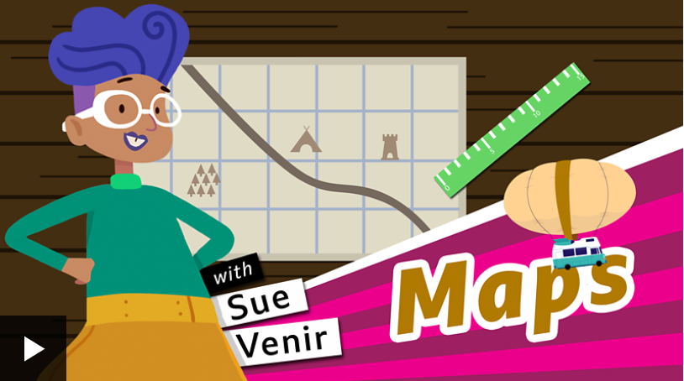 | Activity one  Play this game from the link above.  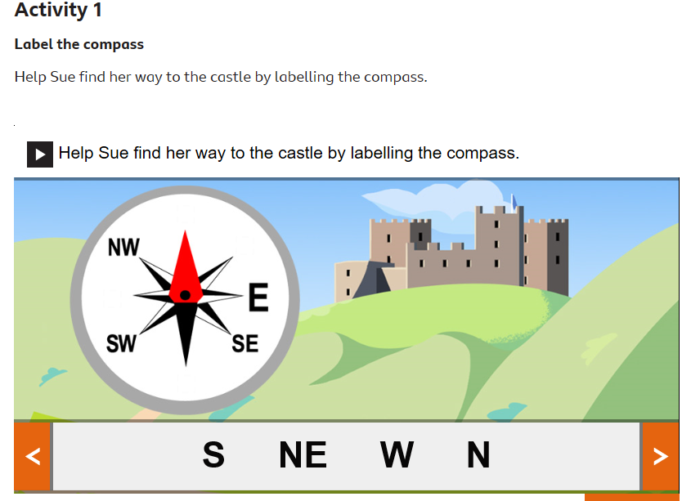
Activity 2  Draw a map of your lounge / front room. Make sure you include details like where the sofa is and where the windows and doors are.  Then ask a parent to hide your favourite teddy in the room somewhere. Then ask them to mark an X on the map, so you can find the item. | Activity 3  Go to Google Maps and find your house. Can you write instructions to get from your house to school? Remember to explain which direction to travel in, the road names and which way to turn.

